1)what is cross site request forgery
It is a web security vulnerability that allows an attacker to trick a user's browser into performing unwanted actions on a different website where the user is currently authenticated (logged in).
An anti-CSRF token (or CSRF token) is a unique, cryptographically secure, and unpredictable value generated by a server-side application to prevent Cross-Site Request Forgery attacks
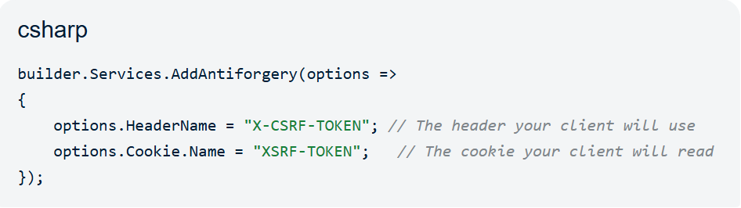
What is difference between storeprocdure and Funaction
storeprocdure Funaction
1) Optional. Can return zero, one,
or multiple result sets. must be return value
here two types scalar means single vale
Tabler means total table data
2)Allowed. Can run INSERT, UPDATE,
and DELETE. Read-only; cannot modify database tables.
3)Allowed. Can use COMMIT and . Cannot manage database
ROLLBACK commands transactions.
4) Create StoreProcedure Create Funcation KeyWord
What is Magic Table
In SQL Server, a magic table ia an internal, virtual table that is automatically created and managed by the database in temporary memory.
Is I do any transactions for every transaction atuomatically saving to magic table
.transaction table replicate of magic table
we have two types insert ,delete.
What is Cluster Index And NonClusteredIndex
Cluster Index: only one Cluster index for one table,And
if we create primary key for any column internally it will create cluster index.
index it will internally set the data and it will reduce the fetching performance.
Cluster Index allows duplicates if it is not a primary key
NonClusteredIndex: More then one non clusterindex we can create
Manullay we need to create non clusterindex

2) write the code to find the value of pi using leibniz formula in .Net
long iterations = 1;
double piOverFour = 0.0;

for (long i = 0; i < iterations; i++)
{
// Denominator: 1, 3, 5, 7, ...
double denominator = 2 * i + 1;

// Alternate signs: subtract if i is odd, add if i is even
if (i % 2 == 0)
{
piOverFour += 1.0 / denominator;
}
else
{
piOverFour -= 1.0 / denominator;
}
}

double piValue = piOverFour * 4;

double pi = 4 * Enumerable.Range(0, 1)
.Sum(n => (n % 2 == 0 ? 1.0 : -1.0) / (2 * n + 1));

Console.WriteLine($"Approximated Pi: {pi}");
Console.WriteLine($"Approximated Pi: {piValue}");
- Console.WriteLine($"Actual Math.PI: {Math.PI}");

3) why multiple inheritance is not support by c#
In C#, multiple inheritance (where a class inherits from more than one parent class) is not supported to avoid complexity and ambiguity. Instead, C# uses Interfaces to achieve similar results.
Class A has a method Display().
- Class B inherits from A and overrides Display().
- Class C inherits from A and overrides Display().
- Class D inherits from both B and C.
The Conflict: If you call D.Display(), the compiler wouldn't know whether to execute the version from Class B or Class C. This leads to unpredictable behavior.
// Anyone can call this.
public void StartEngine() {/* Method statements here */ }

// Only derived classes can call this.
protected void AddGas(int gallons) { /* Method statements here */ }

// Derived classes can override the base class implementation.
public virtual int Drive(int miles, int speed) { /* Method statements here */ return 1; }

// Derived classes must implement this.
- public abstract double GetTopSpeed();

Multiple Interface
public interface ICamera
{
void TakePhoto();
}

// Second interface
public interface IPhone
{
void MakeCall(string number);
}

// Class implementing multiple interfaces
public class SmartPhone : ICamera, IPhone
{
public void TakePhoto()
{
Console.WriteLine("Photo captured successfully.");
}

public void MakeCall(string number)
{
Console.WriteLine($"Calling {number}...");
}
}

class Program
{
static void Main()
{
SmartPhone myPhone = new SmartPhone();
myPhone.MakeCall("555-0199");
myPhone.TakePhoto();
}
}
public interface IPrinter
{
void Print();
}

public interface IScreener
{
void Print(); // Same name!
}

public class SuperMachine : IPrinter, IScreener
{
// This runs ONLY when used as an IPrinter
void IPrinter.Print()
{
Console.WriteLine("Printing to paper!");
}

// This runs ONLY when used as an IScreener
void IScreener.Print()
{
Console.WriteLine("Showing on screen!");
}
}
Why Use a WCF Proxy?
what is constroctor
without constoctor we cant’t implement dependency injection beacues example we want dbcontext so we can asssigne private vearble I have many every time I need to write code .
A constructor is a special method inside a class that runs automatically when you create a new object
A centralized Inversion of Control (IoC) container
• Constructor Runs First: .NET creates a brand-new instance of your class.
• Objects are Created Next: Your database context and repositories are injected or created inside the constructor.
• Method Executes Last: Your specific method runs and sends data back to User A.
• Everything is Destroyed: The moment the response is sent, C# throws away the class and all the objects inside it to free up memory.
Here is the Use of Transiste ,Scoped And singletone
*)For Transient every time create object for service
• Box 1: Object #1 (Used only by the Controller)
• Box 2: Object #2 (Used only by the Order Logic)
• Box 3: Object #3 (Used only by the Database Saver)
*) 2. Scoped = One Object Created
The computer sets aside only one box of memory:
- Box 1: Object #A
- . Singleton = Zero Objects Created (During the request) Globle request
1. Transient (Always New)
The constructor runs every single time a class asks for it. If one request asks for your service three times, the constructor runs three separate times. [1]
2. Scoped (One Per Request)
The constructor runs exactly once per HTTP request. [1]
- Request 1: Constructor runs. The object stays alive while your code processes Request 1. Once Request 1 is finished and sent back to the browser, the object is completely destroyed.
- Request 2: The server treats this as a brand-new world. A brand-new constructor runs to create a completely new object for Request 2. It never reuses the object from Request 1.
3. Singleton (Alive Forever)
If you want the constructor to run only once and never run again for any future requests, you must register it as a Singleton
with constorctor
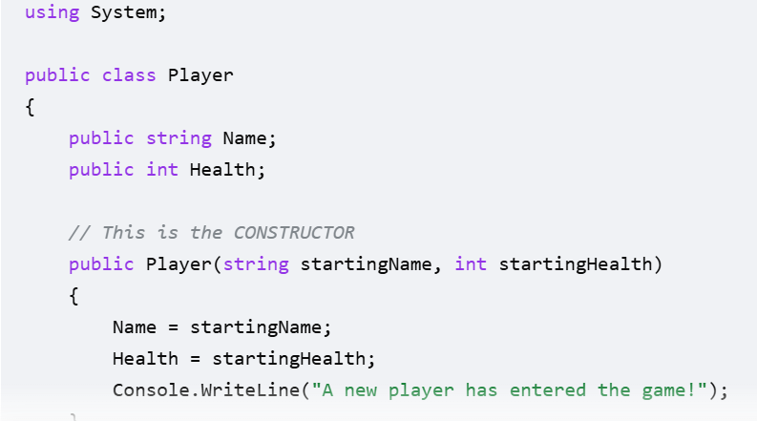
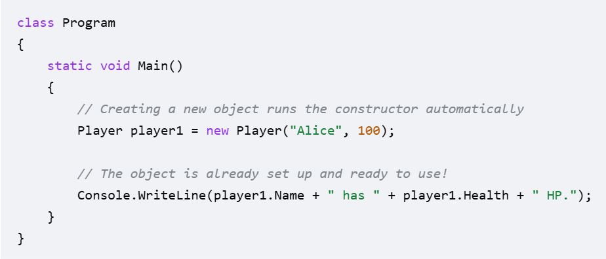
without constorctor
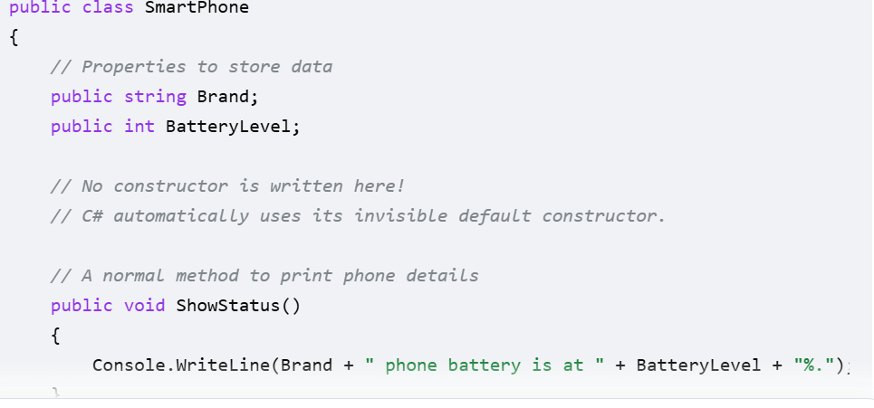
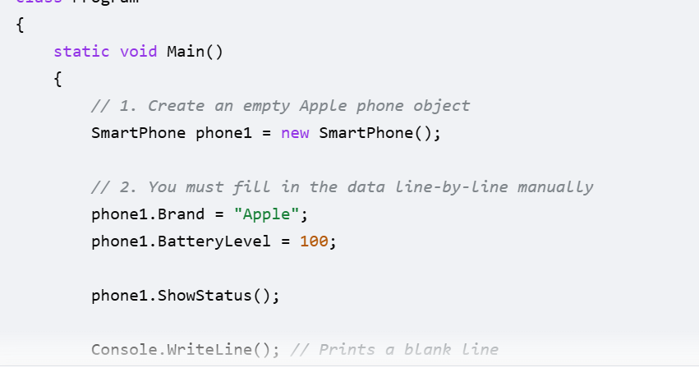
The Big Difference at a Glance
Feature [1, 2, 3, 4] | Without a Constructor (Default) | With a Constructor (Custom)
How you create it | new Car() | new Car("Tesla", 120)
Starting Values | Empty (null or 0) | Filled with your custom data
Safety | Low (easy to forget data) | High (forces you to add data)
Control | Anyone can make an empty object | You control exactly how it is made

- [ServiceContract] (Attribute): Marks the interface as a contract, indicating to WCF that it should be exposed as a service endpoint.
- [OperationContract] (Attribute): Used on methods within the interface to define which operations are part of the service, such as [OperationContract] GetProviderData(int id);
A WCF (Windows Communication Foundation) proxy is a client-side object that acts as a local representative for a remote service, allowing developers to call remote methods as if they were local functions. It abstracts the complexities of network communication, serialization, and SOAP message dispatching.
- Simplified Coding: Instead of writing complex network code, the client calls methods directly on the proxy object.
- Loose Coupling: It separates the service interface from its implementation, allowing the service to change without breaking the client.
- Interoperability: It enables .NET clients to easily communicate with services built on different technologies.
SOAP (Simple Object Access Protocol) is a rigid, standards-based protocol, whereas REST (Representational State Transfer) is a flexible architectural style.
Exclusively XML. | Multi-format: JSON, XML, HTML, Text.
Independent (HTTP, SMTP, TCP, UDP). | Primarily HTTP/HTTPS.

4)lazy binding and eagerly binding in C#
Early Binding
Early binding occurs when the compiler can resolve the method or property at compile time. This is the default and most common behavior in C#.
- Mechanism: The compiler checks that the method exists, matches the signature, and is accessible. It then generates the direct call address in the compiled code.
- Performance: Higher, as there is no overhead for searching for methods during execution.
EX: Method Overloading, Static Method, Standard Instance Calls: Direct calls like myObject.DoSomething().
Lazy binding
Late binding occurs when the method or property is resolved at runtime. The compiler does not know if the method exists or if it is valid; it simply "trusts" that it will be handled when the code executes.
EX. Virtual Methods
4)why are strings in c# immutable are mutable
In C#, strings are immutable, meaning that once a string object is created, its contents in memory cannot be changed. If you perform an operation that seems to "modify" a string (like concatenation), the .NET runtime actually creates a brand-new string object in memory and updates the variable to point to it.
1. What Happens in Memory
When you perform an operation on a string, the original text remains untouched in memory.
- Original String: If you have string s = "Hello";, a memory block is allocated for "Hello".
- Modification: If you then do s += " World";, the .NET runtime does not expand the "Hello" block. Instead, it creates a new memory block for "Hello World" and updates the variable s to point to this new address.
- Garbage Collection: The old "Hello" string remains in memory until the Garbage Collector (GC) identifies that no variables are pointing to it anymore and deletes it.
2. Why Strings are Immutable
Microsoft designed strings this way for several technical and security reasons:
- Thread Safety: Because a string cannot change, multiple threads can read the same string simultaneously without the risk of one thread changing the data while another is reading it.
- Security: Sensitive data like file paths, connection strings, or URLs are often stored in strings. Immutability ensures that a malicious function cannot "tamper" with the content of a string after it has been validated.
StringBuilder
Mutable (can change), Modifies existing object, No, Large-scale text building (loops)
5) what is difference between struct and a class in C
Comparison Table
Feature [1, 2, 3, 4, 5] | Struct (struct) | Class (class)
Type Category | Value Type | Reference Type
Memory Location | Stored on the Stack (fast, temporary) | Stored on the Heap (managed by Garbage Collector)
Copying Behavior | Copies the entire data | Copies only the pointer / reference
Inheritance | Cannot inherit from other classes or structs | Fully supports inheritance
Can be null? | No (always has a value) | Yes (can be null)

12) Main Advantage of microservices? And Difference between windows services and micro services
Local Services, Network Services and System.
Using microservices frameworks results in more scalable, flexible, and easier-to-maintain systems.
A Windows Service is a specific technology for hosting background tasks on the Windows operating system, while Microservices refer to a software architecture style that structures an application as a collection of independent, loosely coupled services.
Specific Technologyy Means : .Net Core ,Asp .Net,Azure Jobs,azure funacations
I had worked on System Services
Key Differences
Feature | Windows Service | Microservices
Definition | A long-running process that starts with the OS and runs in the background. | An architectural style where small, independent services work together.
Hosting | Hosted by the Windows Service Control Manager (SCM). | Often hosted in Docker containers or cloud platforms like Kubernetes.
Platform | Platform-dependent (Windows only). | Typically cross-platform and cloud-native.

- 13) Advantages of stored procedure in sql
A stored procedure (often called a SP or Sproc) is a bunch of SQL code or SQL Queries that you save so you can reuse it over and over again.
pre complied collection of quries saved on the direct in table
whever we have instert into the table instead of writing insert update quries we can create SP we can ruse it whenever we want
15) can we create an instance of abstact class in c#?
No, you cannot create an instance of an abstract class in C# using the new keyword.
other classes inherited this abstract class use abstract properties and methodes
Ex: I craeyted abstract methode shabe and I inheritaed in triangele ,square classes and I passed the prapemeters for abstract metode and in main class I created instance for both the classes an call the abtractclass methode .this is the use for abstract based on the classes parameters we can use this
abstract class is an "incomplete" blueprint. Its purpose is to provide a common definition of a base class that multiple derived classes can share. Because it may contain abstract methods (methods without a body), allowing an instance would mean you could potentially call a method that has no code to execute, which would break the logic of the program.
var myObj = new MyAbstractClass(); It will show compile error
16) What is a Controller in MVC
In the Model-View-Controller (MVC) architectural pattern used in C# (specifically in ASP.NET MVC and ASP.NET Core), the Controller is the central component that manages the application's flow. It acts as an intermediary, receiving user requests from the browser, interacting with the Model to retrieve or update data, and selecting the appropriate View to display to the user.

In C#, a controller is a class that typically inherits from the Microsoft.AspNetCore.Mvc.Controller base class
17) what are action methods
Action Methods are typically two types concepts depends on the context
Action Methods in ASP.NET MVC/Core
1) ction Method is a public method within a Controller class that handles incoming HTTP requests
- 2) Must be public, Cannot be static ,Cannot be a constructor,( getter, or setter) means get set properties ,Typically returns an ActionResult or IActionResult.
2. Action Delegate in C#
In standard C# programming, an Action is a built-in generic delegate that represents a method that does not return a value (void). It is commonly used for callbacks or passing methods as parameters.
using System;

class Program
{
static void Main()
{
// 1. Store the PrintSecret method inside an Action variable
Action myAction = PrintSecret;

// 2. Run the action whenever you are ready
myAction(); // Prints: Shhh! This is a secret message.
}

static void PrintSecret()
{
Console.WriteLine("Shhh! This is a secret message.");
}
}
- Always returns void.
- Can take 0 to 16 input parameters (e.g., Action<int, string>).
- Used frequently in LINQ and asynchronous programming.
19) Design notification system
RabbitMQ
SignalR
20) why pick angular above th js
21) how to handel custem crrors when we have global error handaling in C#
Custom means : we have create
Globale means : Exception by system
2. Implement the Global Exception Handler
In .NET 8, use the IExceptionHandler interface to centralize your logic. Within this handler, use pattern matching to check if the thrown exception is your custom type.
// Register the custom handler
builder.Services.AddExceptionHandler<GlobalExceptionHandler>();
app.UseExceptionHandler();

app.MapGet("/", () => { throw new MyCustomException("Custom error triggered!", 418); });

22)what is AAA in unit testing in C#
AAA stands for Arrange, Act, and Assert. It is a standardized pattern
  - Arrange
Initialize objects , Prepare data
  - Act
- Act: Execute the specific method or action you want to test.
3. Assert
Verify results , Verify state , Check for exceptions

23) what is the first aproch in unit testing in c#

In C# unit testing, the primary and most standard approach for structuring individual tests is the Arrange-Act-Assert (AAA) pattern. Beyond individual test structure, developers often adopt broader methodologies like Test-Driven Development (TDD) or follow the FIRST principles to ensure test quality.
24) what is TDD
Test-Driven Development (TDD) is a software building technique where you write your tests before you write any actual application code.
xUnit.net creates a new instance of the test class for every single test method. This enforces strict test isolation and prevents shared state from causing flaky tests. NUnit, by default, creates only one instance of the class and runs all tests within it, though this is configurable in newer versions
xUnit –[Fact]
n.Unit –[Test]
The TDD Cycle: Red, Green, Refactor
[ 1. RED ] --> Write a test that fails.
| v [ 2. GREEN ] --> Write just enough code to make it pass.
| v [ 3. REFACTOR ]--> Clean up and polish the code.Popular BDD Tools for C#
ReqnRoll, SpecFlow, BDDfy, XUnit/NUnit/MSTest
why we use BDD
Improved Collaboration: Product owners can read and even write the test scenarios in the Visual Studio Gherkin Editor
26) how to eagerly load when lazy loading is implemented in EF core ?
In Entity Framework Core (EF Core), Include() is an extension method used for Eager Loading.
Need to use include() method on the dataset
if we won’t use
Example:
If you query the database without Include, the Books property will be null or empty.
var author = context.Authors.FirstOrDefault(a => a.Id == 1);
// author.Name is populated
// author.Books is NULL
- 27) what are the REST principles in REST API
28) what is difference between filter and middleware

- [Incoming Request] │
- ▼ 1. Middleware (Runs first) │
- ▼ 2. Routing (Finds the controller) │
- ▼ 3. Filters (Runs right before your method) │
- ▼ 4. Your Controller Method Code │
- ▼ 5. Filters (Runs right after your method) │
- ▼ 6. Middleware (Runs last on the way out) │
- ▼ [Response Sent to User]
📊 Direct Comparison Table
- Feature [1, 2, 3, 4, 5] | - Middleware | - Filters
- Where it lives | - The web server level | - The MVC framework level
- What it runs on | - Every request (HTML, CSS, API) | - Only requests hitting a Controller
- Knows about MVC? | - No (Sees raw HTTP text) | - Yes (Sees method names and arguments)
- Can change results? | - Modifies the raw HTTP body | - Modifies the MVC action result object
- 29) can we drop the clustered index in the table in sql server
Yes, you can drop a clustered index in SQL Serve
- Syntax: DROP INDEX index_name ON table_name;
30) can we have more than one clustered index in the in sql server
No, you can have only one clustered index per table in SQL Server.
31) rank dense rank row number cross apply
32) what is mock in unit testing c#
In C# unit testing, a mock is a simulated object used to replace a real dependency (like a database, web service, or another class) to isolate the code being tested. Mocks mimic the behavior of real objects in a controlled way, allowing you to focus purely on the logic of a single unit of code.
Isolation: They ensure that if a test fails, it's due to the logic in your method, not an error in an external system like a Database or Web Service.
- Speed: Mocks run in memory,
- Moq: one of the framwork
To use a mock, you typically mock an interface rather than a concrete class.
33) what is differenence type of inheritance in .Net
Single Inheritance: A derived class inherits from only one base class.
  - Example: Class B inherits from Class A.
- Multilevel Inheritance: A class is derived from another derived class, forming a chain.
  - Example: Class C inherits from Class B, which inherits from Class A.
- Hierarchical Inheritance: Multiple derived classes inherit from a single base class.
  - Example: Class B and Class C both inherit from Class A.
- Multiple Inheritance (via Interfaces): C# does not allow a class to inherit from more than one class to avoid complexity. Instead, it supports inheriting from multiple interfaces to achieve this functionality.
- Hybrid Inheritance: A combination of two or more of the above types, often blending multilevel and hierarchical inheritance
Multiple Inheritance resolved by virtual keyword also
- Hierarchical + Multiple (The Diamond Problem): A base class A is inherited by B and C (hierarchical), and then B and C are both inherited by D (multiple). This creates a "diamond" shape in the class hierarchy.
34) what is difference between out and ref in c#
- Feature | - ref Keyword | - out Keyword
- Initialization (Caller) | - Variable must be initialized before being passed. | - Variable does not need to be initialized before being passed.
- Initialization (Method) | - Method is not required to assign a value. | - Method must assign a value before returning
Example for ref Example for out
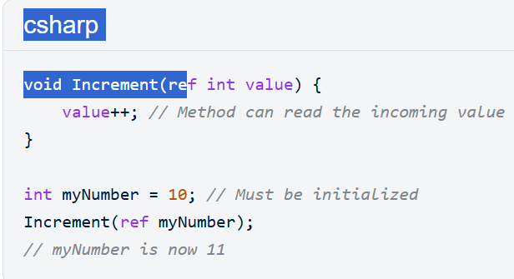 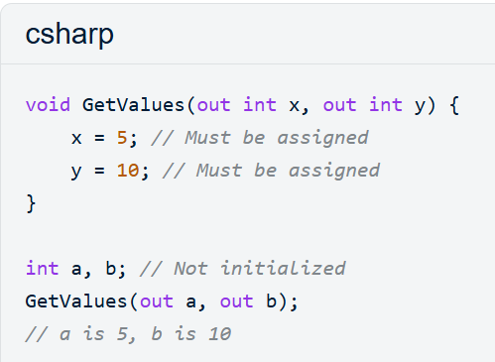
35) What is CTE? will it be stored in database
- A Common Table Expression (CTE) is a temporary,
- CTEs are not physically stored in the database
- Temporary Nature: They act like a virtual, temporary table (or view) that vanishes immediately after the main statement completes.
- Scope: A CTE is only valid for the statement (SELECT, INSERT, UPDATE, DELETE) immediately following it.
A CTE is temporary and exists only for a single query and temporary, while a VIEW is permanent and saved directly inside the database
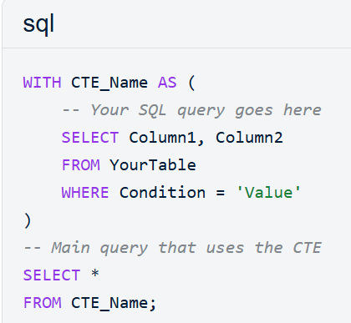

36) what is magic table in sql server
37)How model binding happens in API?
Frombody ,FromRoute,FromQuery
[FromRoute]
- The data is embedded directly in the URL path. It is defined in the route template of your controller or action. Use this when the value
- is mandatory to identify a resource.
- Part of the URL path itself (e.g., /users/5) EX [HttpGet]
2. [FromQuery]
The data is passed as key-value pairs in the query string after the ?. These are typically used for optional parameters that refine a search.
- URL Example: https://localhost:5001/api/users?status=active&page=1
3. [FromBody]
The data is contained in the request body. This is usually reserved for complex objects (like a User object) sent via POST, PUT, or PATCH. Note that you can typically only have one [FromBody] parameter per action.
38) what is difference between select and selectmany in linq

I have two list in that have animals data by using select and select many it will returns like this
Select:Result should be A collection of subject lists (e.g., [ [Apple, Milk], [Bread, Eggs] ]
works like a one-to-one mapping, It takes each element and converts it into exactly one new element
SelectMany: Result should be A single collection of subjects (e.g [ Apple, Milk, Bread, Eggs ]).
works like a one-to-many mapping.
It takes each element, grabs its internal list, and everything down into a single, combined list.
39) what is the clean code principle c#
40) how will you do pagination using linq query c#
To implement pagination using LINQ in C#, the core technique involves combining the .Skip() and .Take() methods.

int pageNumber = 1; // The page you want to view
int pageSize = 10; // How many items per page

var pagedData = sourceList
.OrderBy(item => item.Id) // Always order before paging
.Skip((pageNumber - 1) * pageSize)
.Take(pageSize)
.ToList();
- Page 1: Skip(0).Take(10) (Items 1-10)
- Page 2: Skip(10).Take(10) (Items 11-20)
- Feature | - Build Solution | - Rebuild Solution | - Clean Solution
- Speed | - Fastest (Incremental) | - Slower (Full) | - Fast (Deletes only)
- Action | - Compiles changed files | - Cleans then Builds all | - Deletes output files
- Reliability | - High | - Highest (Clears cache) | - N/A
- Use Case | - Routine development | - Fixing "ghost" bugs | - Preparing for handoff

41) How will you do left join ?right join using Linq
1. Left Join
A Left Join returns all records from the left collection and the matching records from the right
// Sample Data
var departments = new[] { new { Id = 1, Name = "HR" }, new { Id = 2, Name = "IT" } };
var employees = new[] { new { Name = "Alice", DeptId = 1 } };

// TRADITIONAL QUERY SYNTAX
var leftJoin = from d in departments
join e in employees on d.Id equals e.DeptId into empGroup
from subEmp in empGroup.DefaultIfEmpty()
select new { Dept = d.Name, EmpName = subEmp?.Name ?? "No Employee" };

// .NET 10+ NATIVE METHOD
var nativeLeft = departments.LeftJoin(
employees,
d => d.Id,
e => e.DeptId,
(d, e) => new { Dept = d.Name, EmpName = e?.Name ?? "No Employee" }
);
2. Right Join
Standard LINQ query syntax does not have a direct right join keyword. You achieve a right join by swapping the order of the collections and performing a left join. [1, 2]
- Workaround (Swap Collections): Treat the right collection as the left one.
- .NET 10+ Method Syntax: Now includes a native RightJoin() operator. [1, 2, 3]
42) What is the difference between first and FirstOrdefault()
First():If the collection is empty Throws an InvalidOperationException.
Returns the first matching element.
FirstOrDefault():If the collection is empty Returns a default value for the type (e.g., null for objects, 0 for integers).
Returns the first matching element.
43) how to pass data between parent to chaild without using @input and @output ?
Need to use template reference variable @ViewChild. by using @ViewChaild we are grabbing and controlling a child component
@ViewChild("divAccumulatorConfirmPopup", { static: true }) eledivAccumulatorConfirmPopup: ElementRef;

A template reference variable in Angular is a way to declare a local variable within a template that stores a reference to a DOM element, component, or
44) Find consecutive numbers in array?
45) what is pure and impure pipe?
46) what is the trigger ? and how many types of triggers
47) what is intigartion testing?
Integration Testing is a type of software testing and checks if your real code can successfully talk or connect to external systems like real databases, web APIs, or file systems.
Test Frameworks: You use standard frameworks like xUnit, NUnit, or MSTest to write and run the tests.
48) create limitedlist collection in angular // need brief explanation about this
import { Component, signal, computed } from '@angular/core';

@Component({
selector: 'app-limited-list',
standalone: true,
templateUrl: './limited-list.component.html'
})
export class LimitedListComponent {
// Original, full dataset
allItems = signal(['Item 1', 'Item 2', 'Item 3', 'Item 4', 'Item 5', 'Item 6']);

// Limit constant
limit = 5;

// Computed signal that automatically updates when allItems changes
limitedItems = computed(() => this.allItems().slice(0, this.limit));
}
49) how to add new funcationallty to a clsaa which connot be inherited?
using extension methods
In C#, extension methods are a special type of static method that allows you to "add" new methods to an existing type (like a class, struct, or interface) without modifying its original source code, recompiling it, or using inheritance.
• Sealed Class: You can create objects from it using the new keyword. It can hold normal variables and data for each individual object.
• Static Class: You cannot create objects from it. If you type new MyStaticClass(), the compiler will throw an error
How to Create an Extension Method
- Define a static class to house the method.
- Define a static method within that class.
- Use the this keyword before the first parameter to specify the type you are extending. [1, 2, 3, 4, 5, 6]
using System;

// 1. A class that cannot be inherited
public sealed class User
{
public string Name { get; set; }
}

// 2. A static class to hold extension methods
public static class UserExtensions
{
// 3. Static method with 'this' parameter
public static void Greet(this User user)
{
Console.WriteLine($"Hello, {user.Name}!");
}
}

class Program
{
static void Main()
{
User myUser = new User { Name = "Alice" };

// Use the extension method as if it were an instance method
myUser.Greet();
}
}
50) what is the difference between async await and task in c#
A Task is a built-in C# object that represents an ongoing background job..
This is does not return any data (like a void method) The main purpose of a Task in .NET is to prevent your application from freezing while performing heavy work.
Without Tasks: If your app fetches data from a database, the entire program completely freezes and stands still waiting for the database to respond.
With Tasks: The thread running your code drops off the database request as a Task and goes off to handle other work
The main purpose of async and await in .NET is to keep your application responsive and save server memory while waiting for slow operations to finish.
When you use async and await, your program drops off the download request and instantly steps away from the counter.
The main difference is that a Task is an object (a piece of data) that represents a background job, while async and await are code keywords used to control when your program pauses and resumes while that job runs.
async and await are two keywords you add to your methods to handle Task jobs easily without freezing your application screen or console
• Task is an object: Yes! It is the data object that tracks the background job.
• Async to assign work: Yes! The async keyword tells the system this method is ready to assign and manage background jobs.
• Await waits for the response: Yes! await pauses that specific line of code cleanly until the response comes back.
• Task does parallel other works: Yes! While your code is awaiting, the computer is free to run other tasks in parallel so nothing freezes. [1, 2, 3, 4]
Without async/await, you use properties like .Wait() or .Result to get your response, or you use a callback trick called .ContinueWith()
Feature [1, 2, 3, 4, 5, 6, 7, 8, 9, 10] | Task | async / await
What it is | A class (System.Threading.Tasks) representing an operation. | Language keywords (syntactic sugar) for flow control.
Role | The data structure that tracks the status and result of work. | The mechanism to pause and resume code execution.
Thread Usage | Often offloads work to a background thread pool. | Allows the current thread to do other work while waiting.
Blocking | Accessing .Result or .Wait() blocks the thread. | Using await is non-blocking; the thread is released
51) How to pass Expressions to a method?
To pass an expression to a method in C#, you typically use either Delegates (like Func or Action) for execution or Expression Trees for data-like inspection
You write the Expression: (user => user.Age > ▼
2. C# builds the Blueprint (Expression Tree) [1]
│
▼
3. Entity Framework reads the Blueprint and generates SQL string: [1]
"SELECT * FROM Users WHERE Age > 21"
│
▼
4. SQL Command is sent to the Database Server [1]
│
▼
5. Database filters millions of rows and returns ONLY matching rows [1]
│
▼
6. Data is loaded into your .NET application memory [1]

Flow of a Plain Func (Without Expression)
1. You pass a plain Func to the query.
│
▼
2. Entity Framework realizes it CANNOT translate C# binary code into SQL.
│
▼
3. EF turns the query into: "SELECT * FROM Table" (No WHERE clause!).
│
▼
4. SQL Server dumps the ENTIRE table over the network.
│
▼
5. All records are loaded into your local computer's RAM.
│
▼
6. .NET loops through the RAM data and applies your Func filter.
1. Using Delegates (Func<T> or Action) [1]
This is the most common way to pass logic that you want to execute inside the method. [1, 2, 3]
- Func<T>: Used for expressions that return a value.
- Action: Used for expressions that do not return a value (void). [1, 2, 3]
// Method definition
public void ExecuteExpression(Func<int, int> myExpr) {
int result = myExpr(10); // Executes the passed expression
Console.WriteLine(result);
}

// Method call using a lambda expression
ExecuteExpression(x => x * 2); // Outputs 20
2. Using Expression Trees (Expression<Func<T>>)
Use this when you need to inspect the expression (e.g., to translate it into SQL for a database) rather than just executing it. [1, 2, 3, 4, 5]
- The compiler treats this as a data structure rather than just executable code.
- To execute it, you must first call .Compile(). [1, 2, 3, 4, 5]
Example:
using System.Linq.Expressions;

public void AnalyzeExpression(Expression<Func<int, bool>> expr) {
// You can look at expr.Body or expr.Parameters to see what the code does
var compiled = expr.Compile(); // Converts it to a delegate for execution
bool result = compiled(5);
}

// Call it
AnalyzeExpression(n => n > 0);
Compile() transforms this tree into a runnable Delegate
Comparison at a Glance
Feature [1, 2, 3, 4, 5] | Delegate (Func/Action) | Expression Tree (Expression<T>)
Primary Use | Executing code directly. | Analyzing or translating code.
Performance | Faster (directly executable). | Slower (requires compilation to execute).
Context | Standard in-memory logic. | Entity Framework, LINQ to SQL, etc.

52) what is denial of service attack
A Denial-of-Service (DoS) attack is a type of cyberattack that forces a website, app, or server to shut down or crash so that real people cannot use it.
Use a cloud mitigation provider like Cloudflare to filter out attack traffic before it hits your server.
Cloudflare acts as a digital shield that inspects and filters out bad internet traffic before it can ever touch your website. [1, 2, 3]
53) Merge to array and sort them in c# code
1. Simple Concatenation (Best for Unsorted Arrays) [1]
int[] array1 = { 5, 2, 8 };
int[] array2 = { 1, 9, 3 };

// Create a new array with the combined length
int[] combined = new int[array1.Length + array2.Length];

// Copy first array starting at index 0
array1.CopyTo(combined, 0);

// Copy second array starting at the end of the first
array2.CopyTo(combined, array1.Length);

// Sort the result
Array.Sort(combined);

// Result: { 1, 2, 3, 5, 8, 9 }
2. Using LINQ (Most Readable)
int[] array1 = { 5, 2, 8 };
int[] array2 = { 1, 9, 3 };
int[] result = array1.Concat(array2).OrderBy(x => x).ToArray();
54) How will you secure web api in .net core
Securing a Web API in .NET Core requires a multi-layered approach that combines industry-standard authentication protocols with robust server-side defensive practices.
Topics
JWT Authentication: JSON Web Tokens (JWT)
OAuth2 & OpenID Connect: For production-grade applications
secure cloud protocols to safely log users in and manage their API permissions without ever handling or saving their raw passwords in your own database
Role-Based & Policy-Based Authorization: Beyond logging in
It means checking not just who a user is, but what specific things their role or security rules allow them to see and do inside your application.
Enforce HTTPS: Always use Transport Layer Security (TLS) to encrypt data in transit
• CORS (Cross-Origin Resource Sharing): Configure CORS policies to strictly define which frontend origins (e.g., your specific web app domain) are allowed to call your API.
• API Keys: Secrets Management: Continuous Monitoring Logging & Auditing , Security Headers:
55) What is data adapter in ado.net
In ADO.NET, a DataAdapter acts as a central bridge between a database and a disconnected DataSet or DataTable. It manages the flow of data, allowing you to fetch records into memory and later push updates back to the source
SqlDataAdapter in .NET Core need to install some packeges
56) What is CSP in .Net
CSP Meaning [1, 2, 3, 4, 5, 6, 7, 8, 9] | What does it protect? | Where do you use it?
Content Security Policy | Protects browser screens against hackers injecting bad script links. | Built into Web Servers and Browsers (Program.cs).
Cryptographic Service Provider | Protects private encryption keys on a computer hard drive. | Built into the Windows Operating System Core (System.Security.Cryptography).
Content Security Policy
Its main purpose is to prevent Cross-Site Scripting (XSS) attacks. It does this by creating a strict whitelist telling the browser exactly which external files, scripts, images, and fonts are trusted and allowed to load on your website. If a hacker tries to inject a hidden script link into your comments section, the browser looks at your CSP, sees that the link is not authorized, and blocks it instantly
Cryptographic Service Provider
It acts as a hardware or software wrapper box that handles heavy data encryption
digital signatures, and private key storage .Instead of your C# program handling raw secret keys directly in memory, your code tells the CSP box: "Hey, encrypt this file using your internal key database and give me the result back
57) How to create custom model binding in c# example what is the use of this

58) What is Filter()
An array method that sweeps through a list and keeps only the items that pass a specific true-or-false test.
The filter() method works by looping through your array one item at a time, running your test code on each item, and pushing the passing items into a brand new array.
It does not change or damage your original list; it just copies the items that match your rule
59) How to make data entities in ef core threads safe in c#
Entity Framework Core's DbContext is strictly not thread-safe. You cannot execute multiple parallel queries or updates on the same context instance at the same time without crashing your application
Three ways
1.IDbContextFactory:If we inject in it we can do multiple Tasks
2. Always await: always use the await keyword on every EF Core call.
3. Use AsNoTracking()
60) what is difference between ienumerable and iqueryable ,icollection and ilist in c#
The primary difference lies in where the data is filtered and how much control you have over the collection. [1, 2]
- IQueryable filters data inside the Database (Before Fetch).and
- Translates your C# expressions into database SQL text queries before fetching.
- IEnumerable filters data inside your Server's RAM (After Fetch).and
- Executes compiled C# code locally against data already in RAM.
- ICollection allows you to Add, Remove, and Count items in memory.
No. You cannot type collection[2].
- IList extends collection capabilities by allowing you to access items using an Index Position (like list[0])., and You can search, insert, or remove items at specific positions (list[2]).
IEnumerable (Read-only, Forward-only loop) │
├──► IQueryable (Database Provider Queries / SQL Translation) │
└──► ICollection (In-Memory Add/Remove/Count operations) │
└──► IList (In-Memory Index Access like list[0])
61)What is the difference between HasTable And Dictionary?
HasTable is Type Independenat
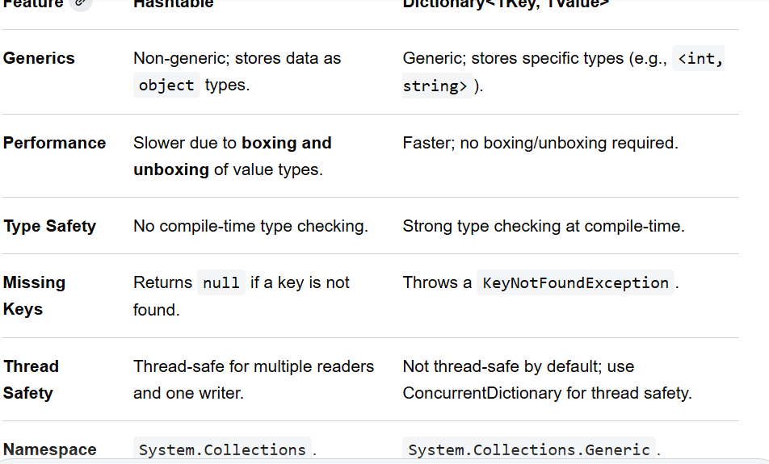
Extra Questions
1) What are delegates In C#?When to use deleagtes in real application ?
A delegate is a variable that holds the reference to method (or) pointere to a methode

A delegate can refer to more then one method have same return type and parameters
when to use
when we need to pass a method as a parameter
Example
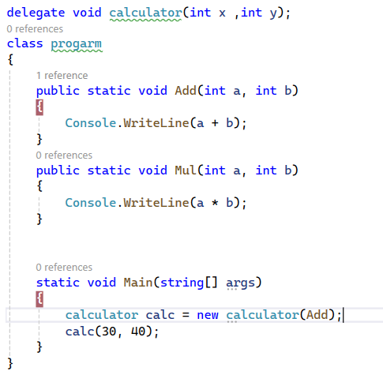
2) what is static class? When to use static class in real appilication?
A static class is a class which object can not be created and which can not be inherited
Use of static class
static class are used as containers for static members like constructor and others
can not create instance members in static class
Example
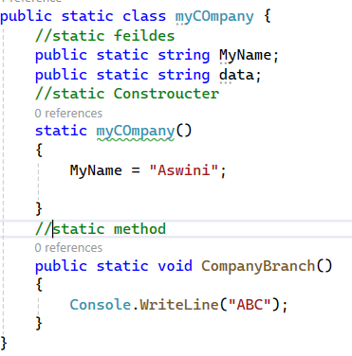
3) What is GAC?
GAC Stands for Global Assemblies Cache
GAC is the place where public assemblies are stored.
Private assembly can be converted into public assembly by adding them in GAC using gacutil tool
4) What are generation in garbage collection?
Garbage collection release the objects which are no longer needed.
.NET framework has a Mechanism to decide which objects are no longer that mechanism we call generations
check in screen shot reaming part
GEN 0:It will check if the A temporary loop variable, a single string value, a small local variable inside a method if mathed edns clan in memory
GEN 1: An object passing data between two different methods that object will not deleted in GEN 0 it will move to GEN 1 if object is shortly finished delete in GEN 1
GEN 2: ConnectionMultiplexer instance, application configuration settings, static variables, or long-running background tasks. All are alive untill your entire application shuts down.leter those all will deleted in GEN 2
5) What is the difference between Task And Threads?what are theadvantages of Task And Threads
In.Net ,Threads and tasks are two different ways for doing multithreading .
Thread is general programming concept .on other hand. Microsoft created task in .Net to simplify the used of threads
Tasks are like wrapper over threads
Tasks internally uses threads only
Thread is like cycle ,task is like bike
Advantages
Simplified code ,Exceptional Handling ,
Task can return result ,but there is no proper way to return a result from Thread
check example in Screen short
6) What is interface segregation principle
The Interface Segregation (ISP) states that a class should not be forced to implement interface that it does not use
without ISP
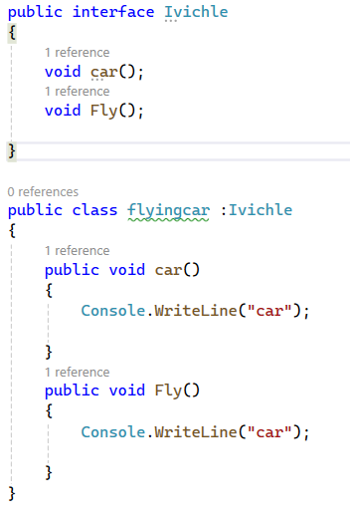
with ISP
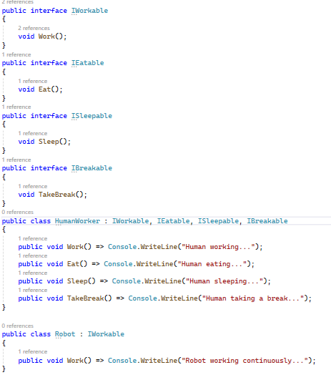
What is dependency injection
Dependency Injection is a software design pattern we can inject dependency object of a class into anther class
What is View
View is an virtual table it continues subset of data for one table r more then one table ,improve the performance and extra security
_____________________________________________________
62) what are events?
The event is a notification mechanism that depends on delegate
An Event is dependent on a delegate and connect be created without delegates
Event is like a wrapper over the delegate to improve its security
Functions ___>Delegates________>Events
Ex) In Asp.Net Web forms we have button events ,dropdown events those all are predefined events under delegate
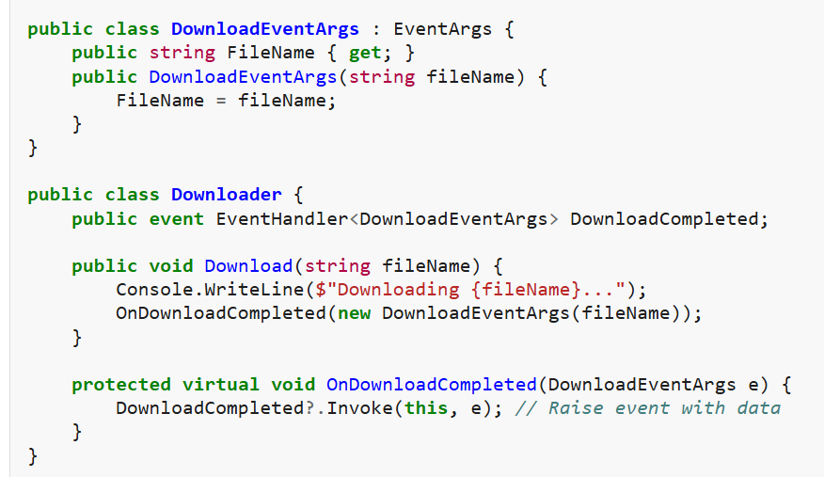
63)Difference between function and action?
Function (Func): Func always returns a value
Action never returns a value (void)
Both are built-in generic delegates and pass methods as arguments

• Action is like a Mail Carrier: You give them a letter (string). They drop it in the mailbox. They do not walk back to you to give you an answer. Their job is just to perform the action.
• Func is like a Calculator: You type in 5 and 10. It does the math and flashes the number 15 on the screen for you to use.
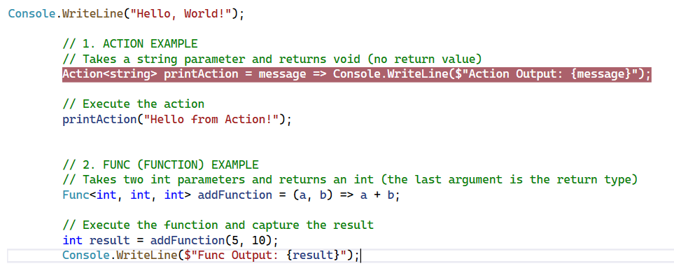
64)Inheritance and virtual override and new keyword?
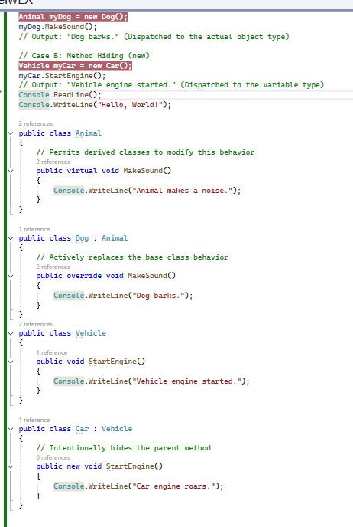
In C#, inheritance allows a child class to inherit members from a parent class, while the virtual, override, and new keywords dictate how methods behave when redefined in that child class.
65) Raising Tempareture?
66) Why use Task When we have async
You cannot use async without Task because they are not competing alternatives. Instead, they are partners that work together to handle asynchronous code in C#
Asynchronous means executing tasks without blocking your application
67) can register custom middleware using app.run() in c#
Yes, you can register custom middleware using app.Run() in C#, but it acts as a terminal middleware.
app.Use:every signal request entering your application by using app.use
app.map: Check the URL path requested by the client if it matched send the request to this specific block of code." Inside that block of code, you then use use app.Run defines the final terminal block that handles the request, stops the pipeline execution, and returns the response without calling the next middleware.

.
68) where we you sore connection string in c#
In C#, you store database connection strings in configuration files outside of your source code, depending on the version of the .NET framework your project uses.
• app.config: Used for Desktop (WinForms/WPF) and Console apps.
• web.config: Used for ASP.NET web applications.
69) what is lunch settings in c# with example
launchSettings.json is an configuration this file we will use for local development to run in Visual Studio no use for QA and Production environment’s
Key Properties Explained
- profiles: Contains the named setups you see in your IDE's "Run" or "Debug" dropdown menu.
- commandName: Tells the system how to boot. Project runs the app directly using Kestrel via C# (.NET CLI). IISExpress targets the lightweight Windows IIS server.
- launchBrowser: Setting this to true automatically triggers your default web browser to open upon startup.
- launchUrl: Appends a specific pathway to the browser startup (e.g., loading http://localhost:5045/swagger).
- applicationUrl: Instructs the local runtime exactly which ports to bind for traffic.
- environmentVariables: Injectable data accessible inside your C# code via Environment.GetEnvironmentVariable().
70) what generic is needed when we have an array list in c#
- The modern generic replacement for a legacy ArrayList in C# is the List<T> class.
// ❌ Legacy Non-Generic
- ArrayList numbers = new ArrayList();
- // Modern Generic Equivalent
- List<int> numbers = new List<int>();
77) How to perform tuning in SQL Server?
To perform performance tuning in SQL Server, you must follow a structured approach that moves from identifying resource bottlenecks to analyzing query execution plans and applying target optimizations
78) Where will static classes be present in memory?
In C#, static classes and their static members are stored in a specialized region of the managed heap known as the High-Frequency Heap (or Loader Heap) within the application domain.
81) How will improve performance of angular application ?dotnet application
1. Change How Angular Checks for Updates
ChangeDetectionStrategy.OnPush: means if i click any buttom or i added one line in one component if ChangeDetectionStrategy.OnPush is not there it will rebuild all the reaming componets also if we use this ChangeDetectionStrategy.OnPush it won't rebuild is changes not there in componets .
2. Use Lazy Loading for Routes
Use Lazy Loading for Routes means insted of loading whole pages dat asplit based on click events get data by using lodercomponet and loderchiled
3. Track Items in Lists
Add a trackBy function to your *ngFor loops
if we use *ngfor one item changes, Angular destroys and rebuilds the entire list on the screen
4. Avoid Complex Code Inside HTML Templates : use a Pure Pipe
5. Use the Async Pipe: means if we connet to HTTP calls inside the app it will take memory space we will hande this automatically clean by using | async Pipe in HTML Templates
6) code splitting ,optimize angular Templates
.Net Performance Concepts:
Chaching,Optimaze database queries ,Asynchoronous programming ,Coonectino polling,
87) what are reflections in c#

reflectino means find out information about assemblies, modules, types, methods, fields, and properties while the application is running
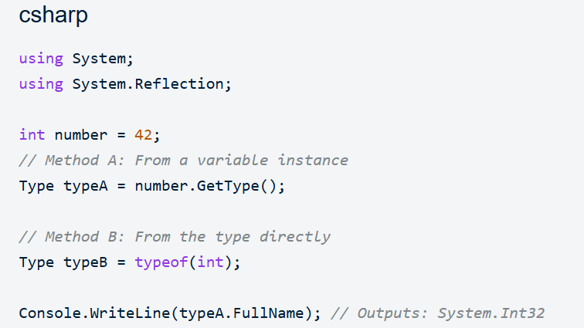 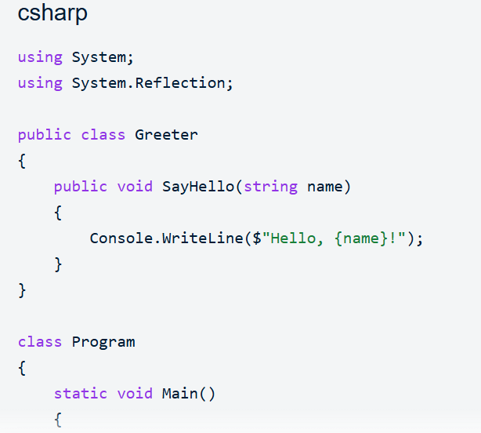 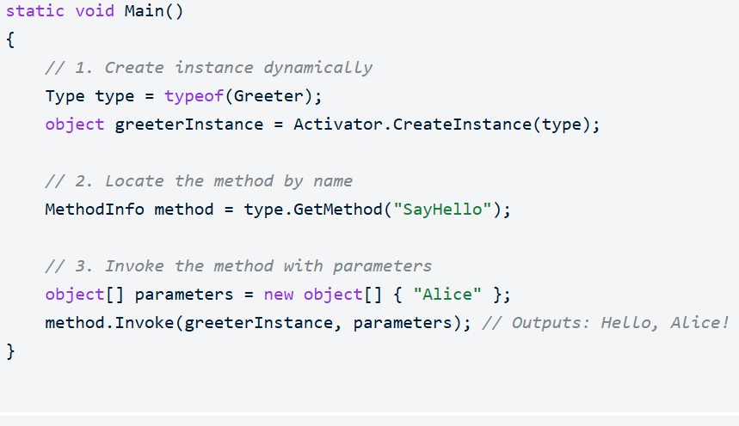
88) what is CLR? -Rules to run code in DotNEt.Once these rules are met will it convert to MSIL?
. Source code convert into MSIL(Microsoft Intermediate Language) verify the CLR(Common Language Runtime) rules later convert into native machin code
CLR Rules
Managed Code and Garbage Collection, CLR Call Just-In-Time (JIT) Compilation and (Convert into Native code), Type Safety and Verification,Exception Management, Thread Management
- Your Code (C#) → converts into → MSIL.
- MSIL → is fed into → The CLR (The Engine).
- The CLR → converts the MSIL into → Machine Code (0s and 1s).

90)what is the difference between singleordefault and firstordefault in c #
Summary Comparison
Scenario [1, 2, 3, 4] | FirstOrDefault() Behaviour |  | SingleOrDefault() Behaviour
0 matching items | Returns default(T) (e.g., null or 0) |  | Returns default(T) (e.g., null or 0)
1 matching item | Returns that item |  | Returns that item
2+ matching items | Returns the first matching item found |  | Throws InvalidOperationException
If more then on elemet is there in sequence it will throw exception in single

- 91) what is refresh token how to implement it?
A Refresh Token is a secure, long-lived string used to request new Access Tokens without forcing the user to log in again with their password. [1, 2, 3, 4, 5]
- An Access Token (usually a JWT) is short-lived (e.g., 15 minutes) for security reasons. When it expires, your client application automatically sends the Refresh Token to the backend API to get a brand-new access token seamlessly
Refresh token is secure and long -lived string it was requested to Asscess Token without Force the user and parallel client application will send a Refersh Token to server valitade and cretate Brand new Asscess Token and then send to clinet
- 92) how does using statement work in c#
using statement manage code execution flow and have automate resource management (close(), despose())once resources work done ( database connection strings ,network sockets) are immediately closed by using statement
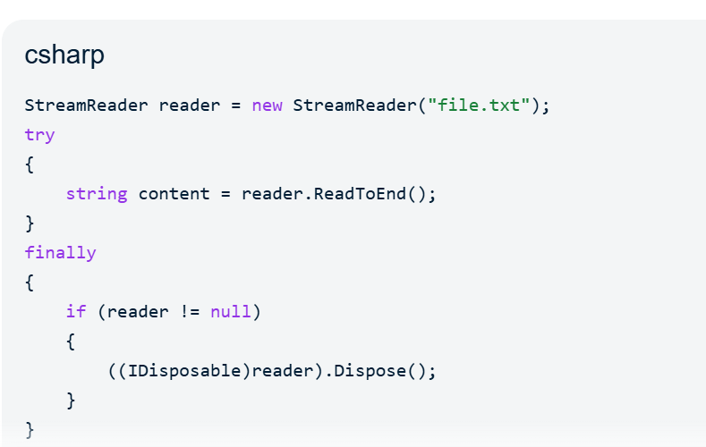
- 93) how to add new table details in db context without scaffolding EF COre DB first approch in C#
To add a new table to your existing Entity Framework Core Database-First context without running the full scaffolding command, you must manually map the table by creating a POCO class and registering it in your DbContext
In C#, get and set are called accessors. They are used inside a Property to control how the data of a class is read (get) and written (set)
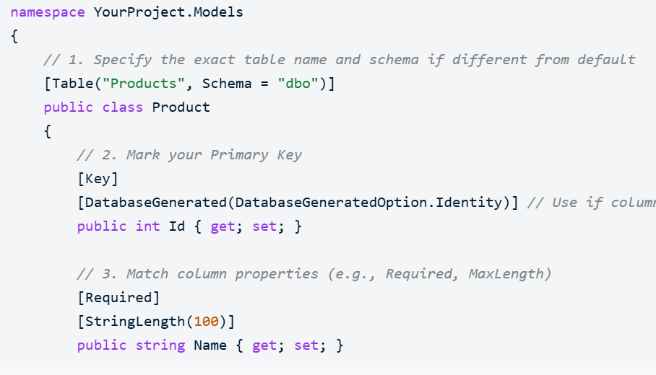
95) how to use sql query in tune query in c#
To tune and execute a SQL query in C#, you must extract your query from the C# application, analyze its performance inside a database management tool, optimize it, and re-integrate it into your code safely.
94) microsoft fakes in unit tests in c# code

Microsoft Fakes is an isolation framework in C# exclusively available in Visual Studio Enterprise that helps you isolate the code under test by replacing other parts of the application with stubs or shims. It intercepts calls to external dependencies like databases, file systems, or third-party APIs so you can test your code in absolute isolation.
Feature [1, 2, 3, 4, 5, 6] | Stubs | Shims
Target Type | Interfaces or virtual methods. | Concrete classes, static methods, non-virtual methods, or sealed classes.
How it Works | Generates a lightweight class implementing the target interface. | Modifies compiled IL code at runtime to detour execution to a custom delegate.
Design Impact | Forces good architectural habits (Dependency Injection). | Ideal for hard-to-test legacy systems or built-in .NET types (e.g., DateTime.Now).
97)What is the difference between 400 bad request and 500 internal server errors
The primary difference is that a 400 Bad Request indicates a client-side error, meaning the user or application sending the request made a mistake, while a 500 Internal Server Error indicates a server-side error, meaning the request was fine but the server crashed or encountered an unexpected problem while processing it
Feature [1, 2, 3, 4, 5] | 400 Bad Request | 500 Internal Server Error
Error Type | Client Error (4xx series) | Server Error (5xx series)
Responsibility | The sender (browser, app, or developer) | The receiver (web server or backend code)
Meaning | "I cannot understand what you sent me." | "I understood you, but I broke internally."
Common Causes | Malformed syntax, invalid JSON, or bad parameters | Code bugs, unhandled database drops, or crashes
How to Fix | Correct the data formatting and resend | Fix the server-side code, configuration, or logic
98) what is route resolver in angular?
An Angular route resolver is a tool that pre-fetches data before a page loads.
How it Works
- You click a link to go to a new page(or next page).
- The resolver stops the navigation for a moment.
- It talks to the server to get the required data.
- Once the data arrives, the page opens with the data already visible
99) what is canactivate and canactivechild angular
/admin (Parent Route) ──► Protected by [canActivate] │ ├
── /admin/users (Child 1) ──┐
├── /admin/billing (Child 2)
└── /admin/settings (Child 3) ──┘
├──► All protected by a single [canActivateChild]
Angular, canActivate and canActivateChild are Route Guards.They are used for to control the application navigation.
canActivate : used for protect main route means parent componet route itself.
canActivateChild : used for protect all chaid routes means under the one perent componet we have more then one chaild it will control all the chaild componets and routes
100) what is anonymous controller
An anonymous controller (often called an anonymous or unauthorized endpoint) is a controller in a web framework—such as ASP.NET Core or Angular—that explicitly allows access to its endpoints without requiring user authentication or authorization tokens.
- 101) what happens when table have more in dexes when select are update in SQL
Faster SELECT Queries: While updates slow down, SELECT queries that filter by or sort on those indexed columns will run much faster. [1, 2]
102) what is difference between CTE and TEMP Table?
- Feature [1, 2, 3, 4, 5, 6, 7] | - CTE (Common Table Expression) | - TEMP Table
- Scope | - Limited to the single query, batch, or statement that defines it. | - Exists for the duration of the entire user session or stored procedure.
- Storage | - Stored entirely in memory (RAM). Not saved to disk. | - Stored physically on disk in the tempdb database.
- Reusability | - Cannot be reused in separate, subsequent queries. | - Can be referenced multiple times across different queries in the same session.
- Indexing | - Does not support indexes. | - Supports indexes and constraints, much like a regular table.
- Recursion | - Fully supports recursive queries (e.g., organizational charts or bill of materials)

103) What is URL encoding
URL encoding (officially called Percent-encoding) is a mechanism used to convert characters into a safe format that can be transmitted over the internet
ASCII character set
104) Fault tolerance microservice
Fault Tolerance is an design pattern for applications .we operate any application in Fault Tolerance if any individual service have crashed and network failure it would continue operate it won't stop.
105) fork join in angular example
forkJoin is a powerful RxJS creation operator if fetches data from two different API endpoints Instead of an array, you can pass an object dictionary to forkJoin if any is thrown error from one observables it retuns error if fetched data from both observables and combined the data return

106)What is asynPipe in angular
The async pipe (AsyncPipe) is a built-in Angular template pipe that automatically handles asynchronous data streams directly within your HTML code
107)paas saas
PaaS (Platform as a Service): (like Azure App Services). You write the code and manage the databases, but Azure handles the servers and runtime execution engine.
SaaS (Software as a Service): we have to use complete software application (like Gmail or Salesforce). You do not write code; you simply log in over the internet to consume the software.
108) How to handle messages when queue is full in microservices?
we have three core strategies
Dead Letter Queues :store all failed measseges in sepreate continer
Backpressure and Circuit Breakers:Send HTTP 429to the client
Dynamic Consumer Auto-Scaling:process the backlogged messages faster
108)What is debug deadlocking in sql server
109) unit testing static classes C#
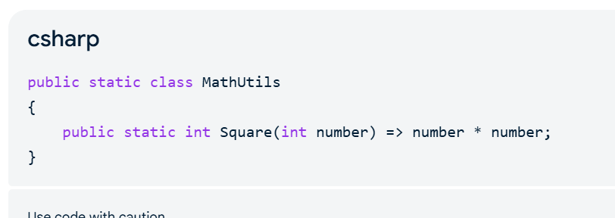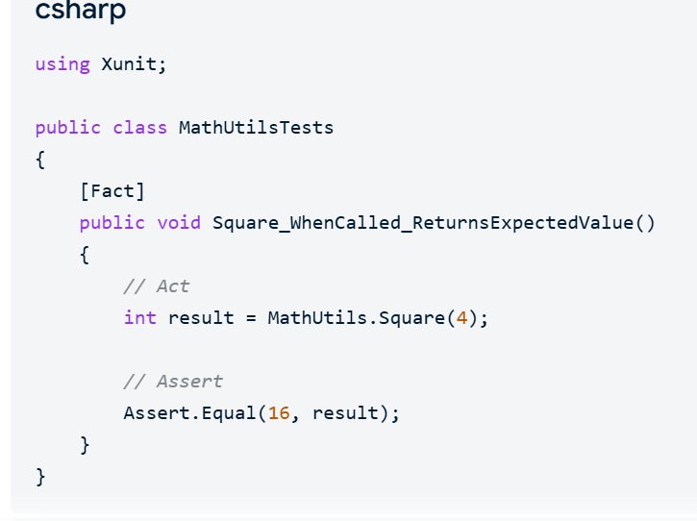
110) how to pass parameters for extension method in c#
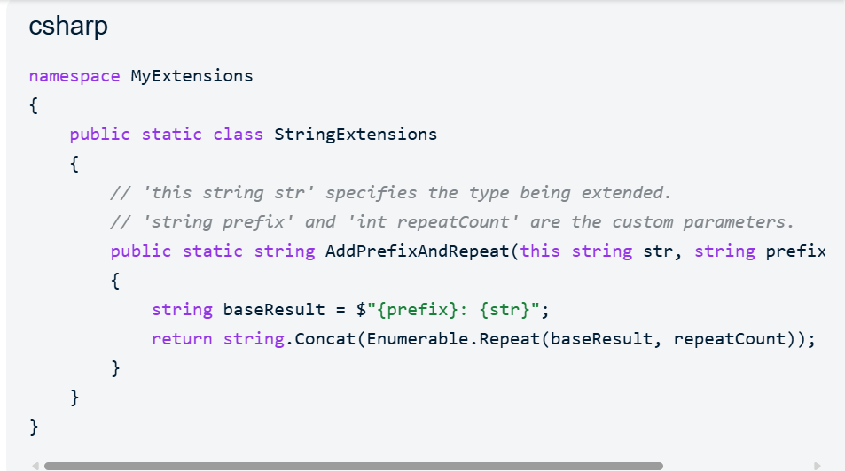
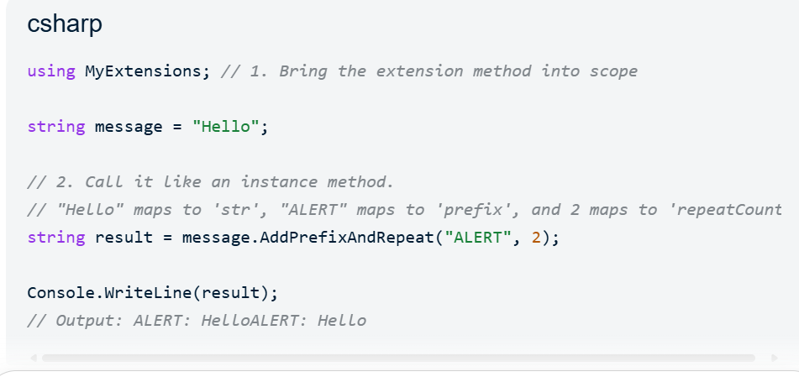
112) when post method has created to be used for get request itself c#?
You can absolutely use a POST it slightly violates standard REST API rules which can confuse other developers who expect data fetching to use GET
113) can function have insert statement in sql?
Generally, an SQL User-Defined Function (UDF) cannot contain an INSERT statement that modifies permanent base tables.
114)Delete and truncate difference?
Feature [1, 2, 3, 4, 5, 6, 7, 8, 9, 10, 11, 12, 13, 14] | DELETE | TRUNCATE
Command Type | DML (Data Manipulation Language) | DDL (Data Definition Language)
WHERE Clause | Supported; allows you to filter and delete specific rows. | Not supported; completely empties the table.
Speed | Slower; logs each deleted row. | Faster; deallocates data pages instead of scanning rows.
Rollback | Supported; changes can be undone before they are committed. | Generally cannot be rolled back in most databases.
Auto-Increment/Identity | Retains the current value (e.g., if you delete row 10, the next inserted row will be 11). | Resets the identity counter to its initial seed value.
Triggers | Fires row-level triggers defined on the table. | Does not fire triggers.
Aother Questions
• Authentication is proving WHO you are (Logging in).
• Authorization is checking WHAT you are allowed to do (Permissions).
1) Types Of Authentications
4 types of Authentications
1. Cookie Authentication: Based on your password and username first server will check valid or not later it will create on cookie file and drop on the browser if we click on the next page attache that cookie file and check user still loggined or not
Best for: Monolith web applications, like ASP.NET Core MVC or Razor Pages
2. Token Authentication : You are loggin server generates JWT Token and tha client application saved this token and send to server for every request in headers
Best for: Mobile apps, Single Page Applications (SPAs), and Microservices.
3. Third-Party / OAuth Authentication : if I am loging into Google and again it will send digital security note back to your app
This is best for public web apps
4. Windows / Integrated Windows Authentication : if you log in your office windows you can access company apps without asking login details
SOLID
S – Single Responsibility Principle (SRP) [
- The Rule: A class should have only one job don’t domultiple jobs
O – Open/Closed Principle (OCP)
. The rule :we can add new funcationlity but don’t change old working code
L – Liskov Substitution Principle (LSP)
- The Rule: A child class must be able to replace its parent class completely without crashing or breaking the application.
I – Interface Segregation Principle (ISP)
. the interface segregation principle states that class shouldn’t implement interface no use with that class
D – Dependency Inversion Principle (DIP)
Loosely coupled using an abstraction socket (Dependency Injection)
the high- level business logic should not depends on low level databases must be depends on interface
In Angular, Eager and Lazy loading
In Angular, Eager and Lazy loading are about WHEN code or data is fetched from the server into your computer's memory
• Eager Loading: Downloading all pages and features upfront from the server the very first time you open the application.
• Lazy Loading: Downloading only the main page at first, and fetching other pages from the server on-the-fly only when you click a button

if i open my application first time it is loading home page at a time from server this is called eager loding when i click on any boutton again it will fetch data from server and disply this is called lazy loading right
Why .NET Core is better then .NetFramWork
High-performance Asynchronous (async/await) engines.
Built-in Dependency Injection (DI) for writing SOLID code.
Modern request pipelines using app.Use() and app.Map()
• .NET Framework: Only runs on Windows servers. You are locked into Microsoft operating systems.
• .NET Core: Runs perfectly on Windows, Linux, and macOS
3. Modular Construction (Lightweight)
☁️ 4. Built for Cloud and Containers (Docker)
What is CORS
CORS (Cross-Origin Resource Sharing), it is a browser security guard we got any request from that Browser CORS will check we are reciving valid localhost are not.
What are REST Principles And REST APIs
REST (Representational State Transfer) is an architectural style (a set of guidelines) for designing web services
Uniform Interface: Elements use a standardized communication contract (like URLs and HTTP methods like GET, POST, PUT, DELETE).
Client-Server Separation: The user interface (client) and data storage (server) operate independently.
Statelessness: Every single request from a client must contain all necessary data.
Cacheability: simply means the server send responese to clint Inside that response, it tells the client it is allowed to save a copy and reuse it later .
Layered System: The client can never tell if it is connected to the final server or an intermediate step like a security gateway or load balancer.
Code on Demand (Optional): The server can send executable code fragments (like JavaScript files) directly to the client runtime
REST API
- way for two computers to talk to each other over the internet
REST API Means Send the request from clint and Delivery the request to API fetch data from Database and send the response back to client this procees over internet
What IS Middleware
middleware is checkpoint it will check Request ,insepects ,block the requwst befor reaching to database ,check the resonse before goint to clinte .
Clean Code Principles
easy for human beings to read, understand, and change (which includes naming, formatting, function sizes, and SOLID).
What is Model Binding
Standard Model Binding:
- The client sends ?colors=red&colors=blue. .NET automatically puts this into a List<string>.
- The client sends a JSON body like {"name": "John", "age": 30}. .NET automatically maps it to your public class User
Custom Model Binding :
Custom Model Binding is like if send data string fornate manullay i split that and stroe in LIST so i have to do coustome model in server side .
89)What is Manged Code and UnManged Code
1. Managed Code Runs in CLR, JIT converts MSIL into Native code, automatic memory management, works for High-Level Languages like C#, Java, and F#.
2. Unmanaged Code Runs directly on the CPU, converts directly to native code, manual memory management, works for "low-level performance" languages like C and C++.
94)What is Microsoft Fakes in Unit Testing
Microsoft Fakes is a testing framework that contains two components: Stubs and Shims. It stands out because it can hijack and rewrite compiled, concrete binary code at runtime.
- Stubs are used for clean architectural code layouts (like interfaces). The framework automatically generates these mock objects and prefixes them with Stub.
- Shims inject runtime detours. Instead of calling the real concrete method, the application redirects execution to your custom test logic. The framework automatically generates these with a Shim prefix.
- Example for Shims: If production code depends on a hard-to-test system component (like DateTime.Now), a Shim intercepts that call internally and forces it to return custom test data (like forcing the system to think it is Sunday).
96)How to mock class using moq
Methods and properties must tb virtual and create Mock instance and MockServices
________________________________________________________________________________________
Angular Questions
1)what is pure and impure pipes in angular
Pure pipes are the default type of pipe in Angular like DatePipe, UpperCasePipe, and CurrencyPipe
Angular runs an impure if we did any change in the component (arry ,object might changed)this called impure pipe
2) what is LimitedList
A LimitedList keeps the array length fixed, and once the maximum limit is reached, any new items are completely ignored and rejected.
3) what is factory and simple factory
simple factory and factory both are disgne paterens in simple factory uses a single class with conditional statements but in Factory Pattern delegates object creation to subclasses through inheritance
4) what is generic functions in angular
a reusable piece of code that can work with different data types while maintaining strict type safety
5) What is As Const and Const
Const is we can modify As Const we con't modify and immutable and freez the objects
6) what does private access modifiers do whan addes to a class variable /method
We con’t modify out of the class
7)what is decarators in type script
decorator we have four type class ,method ,property and parameter and mostiy used for reusable code
8) What is interface and type
Use interface for data is coming from API we can directly mas to object strucatures
use type fro funaction signatures
9) What is Type Guard
A type guard checks the variable's type at runtime so that it will check if staments and open spelcific block code
10) What is Structural typing and Nominal typing
Structural typing cares only about the internal shape (matching properties) means i have two class have same type so i can create object from one class to anthore class
EX:Python
Nominal typing uses explicit inheritance lineage to allow you to store a child object inside a parent container
EX:C#,java

11) Difference between Angular and Angularjs

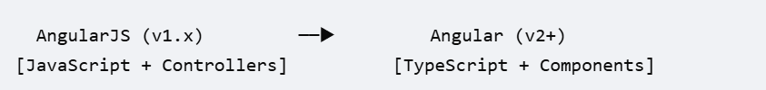Architecture Model-View-Controller (MVC) Component-Driven Architecture
Data BindingTwo-way data binding One-way and property data binding
(can cause slow UI updates) much faster)

12) Difference between componantes ,dricatuves and services
Components define user interface views
Directives add reusable behavior or styling to existing HTML elements
Services Fetches data from an API and makes it accessible across multiple components
13)Difference between reactive froms and template driven froms
Reactive Forms mange inside the TypeScript component class and data flow is synchronus create excplitly Control via FormControl, FormGroup
Template-driven Forms mange inside html And data flow is Asynchronous implicit control via ngmodel directive
14) what is observables and how are they used with RxJS
Observable is a blueprint that describes a stream of data or events over time
is read the data and disply in the UI
RxJS (Reactive Extensions for JavaScript) is the library that provides the operators to combine, filter, and transform those streams
is filtering the data and send final output

[ Data Source ] ──▶ ( Create Observable ) ──▶ [ RxJS Pipe / Operators ] ──▶ ( Subscribe ) ──▶ [ UI / Action ]
15) What is binding and it types
Interpolation (One-Way: Source to View)
Interpolation is a one-way binding that only pushes data from TypeScript to display as text on the screen
Interpolation data flows is typescript to HTML view it only reads the data disply in UI Two way data binding based on the user input on the screen automatically update in type script code
propery data binding onw way data flowing set of attributes inside the Html
[Disbled]
event data binding nothing but triiger the methode and do action
Interpolation: TypeScript ───────────────► HTML View (Text Only) Two-Way Binding: TypeScript ◄◄─────────────► HTML View (Inputs) Property Binding: TypeScript ───────────────► HTML View (Sets an Attribute) Event Binding: TypeScript ◄─────────────── HTML View (Triggers a Action)
Two-Way Binding
while Two-Way Binding links data in both directions so that user inputs automatically update the TypeScript code in real-time.
16)how to handl e HTTP requests using Httpclieant in angular
HttpClient executes asynchronous backend API requests by returning cold RxJS Observables,and display live server data in your UI while protecting the app from memory leaks
17) Explain change detection in angular
In Angular, Change Detection is the built-in mechanism that synchronizes the application's TypeScript data model with its HTML template view .
Change Detection in build mechanism if i update any property it will disply with updated data
18) difference between *ngif and hidden in angular tamplates
*ngIf physically adds or removes the element from the DOM tree,
[hidden] keeps the element in the DOM but uses CSS to hide or show it
The DOM (Document Object Model) is a programming interface that represents a webpage's HTML structure as a tree of objects
19) Best way to pass data between parent and child componants
Use input() to push data down from Parent to Child.
Use output() to send events up from Child to Parent.

20) how to manage state effectifly using NgRx and Redux
it was strictly mange the unidirectional data flow with three core pillers store ,Action and reducesrs and selectors
a single source of truth (Store),
immutable state modifications (Actions and Reducers),
and performance-optimized data reading (Selectors]
21) What is AuthGuard
Auth Guard control application security by checking a user's authentication or permission before allowing access to a specific web route
SQL Questions
________________________________________________________________
1)what is transaction
a safe and reliable unit of work
2)what are ACID Properties
Atomicity: A transaction is treated as a single, indivisible unit of work
Consistency: A transaction can only take the database from one valid state to another valid state.
Isolation (Independence)
Multiple transactions can run concurrently without interfering with each other.
Durability (Permanence)
Once a transaction is successfully committed, its changes are permanent
3)What are indexes how they will perform
index is a specail data structure it will divides the data in sets in internally for fast fetching
4)Difference between DELETE ,TRUNCATE and DROP
DELETE removes specific rows based on a condition and logs each deletion, allowing recovery.
TRUNCATE empties the entire table instantly by deallocating its storage pages with minimal logging.
DROP completely destroys the table's structure, rules, data, and indexes from the database permanently
5)What Is DeadLock
A deadlock is an unwanted database error (Error 1205)
DeadLock means multiple users can't excute the same query on same data at time withoutlocaking the session
Yes, using WITH (NOLOCK) can prevent a deadlock
6)Difference between primary key and unique
Primary key does not allow null values
unique key allow one null value because it is also unique
7) What is Rank ,Densrank,Row Number ,CrossApply
Row Number: It Assigens the sequential rank number to each unique record
Rank: It assign the rank number to each record in a partition .it skips the numbers for similar values
Densrank,Row: It assign the rank number to each record in a partition .it Doesn’t skips the numbers for similar values
CrossApply
Why we are using CrossApply we will get Top records from table instead of using joins right(littil bit difficult again we need to use row number)
• CROSS APPLY: If a row from the left table has no matching data on the right, it is deleted from the final results.(inner join)
• OUTER APPLY: If a row from the left table has no matching data on the right, the left row stays, and the missing right-side columns are filled with NULL.(outer join)
8)Difference between CTE and Temp table
CTE: we have excute CTE along with select statement and if we excute CTE it will impact main table
Temp table: we can excute select in that session only ,it won’t impact main table
9)How to use SQL profiler to fine tune query
it is a four step process fris captuer real-time database trafic next identify worst performing querise send to database engine tuning advisor for atomuted optimazation suggestions
what is the main use of coursor
The main use of a cursor in SQL is to process a query result set one row at a time (row-by-row) rather than all at once (set-based).
Degrade the performance
• DECLARE ... CURSOR FOR: Links your loop directly to a database query.
• OPEN: Executes the query and prepares the records for looping.
• FETCH NEXT INTO: Grabs the values from the current row and assigns them to your variables, moving the pointer to the next row.
• @@FETCH_STATUS = 0: A global SQL system function that returns 0 as long as there are still rows left to read. It changes when the loop hits the end of the data.
• CLOSE & DEALLOCATE: Completely removes the cursor from memory so it does not lock your database tables or waste server resources.
Concepts
1) table creation,Proc,Joins,subquery,Row,rank,DenskRank,second Highest salary
___________________________________________________________________________
Reaming Dot net Questions
1)What is gRPC
gRPC is a high-performance framework that connects microservices across different languages using fast HTTP/2 streaming and compact binary data
Feature | gRPC | REST API
Data Format | Binary (Protocol Buffers)  08 65 12 05 41 6C 69 63 65 | Text (JSON or XML)  {"id": 101, "name": "Alice"}
Payload Size | Ultra-small (highly compressed) | Larger (heavy text overhead)
Transport | Strictly HTTP/2  hundreds of requests and responses at the exact same time over a single connectio | Usually HTTP/1.1  One Request at a Time: A TCP connection can only handle one request and one response at a time. If a REST API sends 3 requests, it must wait for Request 1 to finish completely before Request 2 can start
Core Design | Remote actions (e.g., createUser()) | URL resources (e.g., /users)
Streaming | The client and the server can talk to each other at the same time continuously | Limited (Server-Sent Events only)
Browser Support | Requires a proxy (gRPC-Web) | Native (works in all browsers)
2) what is difference between equals() and == .net core
Feature | == Operator |  | Equals() Method
Null Safety | Safe. Returns false if one side is null. |  | Risky. Throws a NullReferenceException if the calling object is null.
Polymorphism | Resolved at Compile-time (Static binding). |  | Resolved at Runtime (Virtual/Dynamic binding).
3) Difference between controlerbase and controler
ControllerBase: The parent class. Use it for RESTful Web APIs to return raw JSON data. It does not support Razor views.
• Controller: The child class. Use it for MVC Web Applications because it can do everything the parent does (return JSON) plus render HTML/Razor Views
4) Explain Microservice Architecture and how to impleamnet in .Net core
Microservice Architecture is a design pattern large application splits into small ,independent and loosly coupled services .Each service foucuse on single busness service
5) explan chaching strategeies
Chache Stroe the data in Ram when any request came from client it will fetch from cache
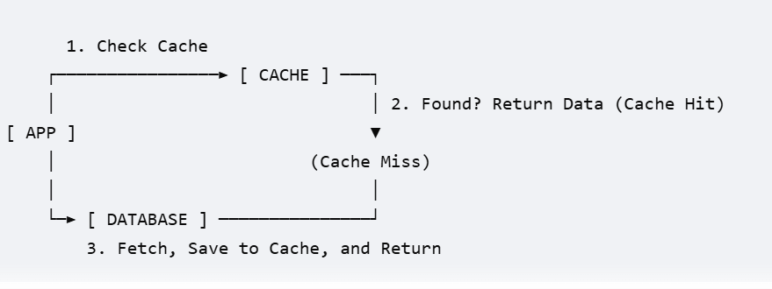

6) what is Value Type and Reference Type
Value types store their actual data directly inside their own memory space
Example : int, bool, double, struct, enum
Reference types store a pointer (a memory address) that points to the data located elsewhere.
Example: class, string, array, interface
7) what is IConfiguraton
IConfiguration is an interface it will read the configuration settings means App.settings ,App.config files
8) What is the Options pattern
OptionPattren is like Iconfiguration but optionpatreen is strongly typed access and we can implement like this create simple class and add dependency injection continer and injectIpotions we can read the appsetting and Appconfig
9) what is model validation
It prevents bad or malicious data
inspects the data it is accurate before application processing it
10) what is API versioning
API versioning is nothing you can update fetures and modify data structures without braking exisiting frontend
11)What is enetity Framwork core
Entity Framework Core (EF Core) is an open-source, lightweight, and extensible Object-Relational Mapper (ORM)
Bridge between your object-oriented C# code and a relational SQL database
12)what is difference between code first and database first
• Code-First: You write the C# class first in .NET, connect to the server, and EF Core creates the database table automatically to match your class blueprint. [1]
• Database-First: You write the SQL table first in SQL Server, and then run the EF Scaffolding command to let it read your database and automatically write the C# class files for you
13)What are Migrations
Migrations in built
Migrations are Entity Framework Core's automated way of updating your database schema when your C# data models change
14)what is difference between eager loding ,lazy loding and explicit loding
Eager Loading: Load All queries in one single query using SQL joins
Lazy Loading:Dealys the children loding untill physical Access
- Explicit Loading: we have to call .Load() method expilicitly
15)What is LINQ
LINQ (Language Integrated Query) we can query on databases,Json to get data with LINQ condition
16)How do you improve EF core performance
minimizing database roundtrips, reducing the data payload,check when to use Savechanges() and AsNoTracking()
17) What is AsNoTracking()
AsNoTracking() it is a methode in EF core it will reads the data only we can use this beacuse EF core internally copy two copies save the changes in one copy if we use savechanges() it will compare both the copies ans save in DB.if we are not updateting anything DB we can simply use AsNoTracking() for read only
18) how to handel transactions in EF core
every time we have to call SaveChangesAsync() so all transactions are automatically saved in DB
19)Explain repostry patreen and unit of work patreen
architectural design patterns used together to isolate your business logic from the database code
Repository: Acts as an In-Memory Collection and Prepares and holds individual data pieces in memory (Waiting Room).
The Repository Pattern is a popular architectural design pattern used in .NET Core to create an abstraction layer between your business logic (controllers, services) and your data access layer (Entity Framework Core, Dapper, SQL database).
- Unit of Work: Acts as the Transaction ManagerTakes all those waiting pieces and executes the single send to the Database (The Green Light). [1]
The Unit of Work pattern is an architectural design pattern that groups multiple business operations (like inserts, updates, and deletes) into a single transaction
20)why we are giving preference to microservice instead of Monolith services
Everything runs in a single process.
21)how to microservices comminicate each other
microservices
microservices architecture, you break your backend into multiple, independent APIs (services) that communicate directly with each other internally, rather than forcing the Angular frontend to coordinate those calls
Synchronous communication: simply I have to services ihave to call service A to service B
Use gRPC when service A needs a direct answer right now from service B to continue
Asynchronous communication :
RabbitMQ (Asynchronous / Indirect): Service A drops a message into a queue and hangs up immediately. It does not care when Service B processes it, or if Service B is even online at that moment
If you use the Fire-and-Forget pattern, the communication is considered Asynchronous because the first API doesn't wait for the task to finish. Without this (or a message queue), standard API-to-API communication over HTTP is always Synchronous, because the first API must keep the connection open and wait on the line for the second API to send back a response payload.
Synchronous communication (direct, immediate requests like gRPC or REST) and Asynchronous communication (indirect event messages via a broker like RabbitMQ)
windows services And system service both are same
scheduled service nothing like what I used in AKKA.net time scheduled
Yes, an Azure Function can be considered a worker service, Hosted in the cloud
22) what is an API gateway
An API Gateway is a server that acts as a single entry point (the front door) for all client requests coming into a microservices-based application
Angular - API gateway order microservice
payment microservice
Dispatch service
23) how do you mange distribute transactions
using the Saga Pattern
Saga Pattern
maintain data consistency across multiple independent services and databases
distributed transactions by splitting a large, multi-service operation into a series of small, independent local transactions
24) what are the major chalagess in microservice Architecture
The major challenges are managing distributed data consistency without SQL locks, handling complex network communication latency, and tracking down bugs across scattered application logs.
____________________________________________________________________________________________
SQL Server Examples

1)What is constraints
The specification of the table column’s
• PRIMARY KEY: Uniquely identifies each row and forbids empty values.
• FOREIGN KEY: Links rows to another table to prevent broken relationships.
• NOT NULL: Forces a column to always contain a value.
• UNIQUE: Guarantees all values in a column are completely different.
• CHECK: Verifies that values meet a specific condition before insertion.
• DEFAULT: Injects a preset value if no data is provided.
When ever we have given identity should be apply not null,
If we rename column name first create new column name migrate the data later delete the column
if we add constrains for not null we have to check null dat is there are not later add not null
we connt rename the column have contrints add new column update the data and delete the column
add we con’t drop the column if column have constraint first we have to drop the constraint and next drop column
compositi primary key
composite unique key
INDEX
We have three types
Index ,clusterindex ,nonclusterindex
internal have two types compositeindex ,unique index
Views,TempTable,CTE
store proceducer
to get the business logic
Begin end
begin trans commite use this utill it will complete it won’t do other transactions
Joins
1. INNER JOIN
returns rows when match in both tables
select a.* ,b.* from JoinTable1 as a
inner Join Jointable2 as b
on a.JoinId =b.JoinId2

2. LEFT (OUTER) JOIN
Definition: Returns all rows from the left table, and the matched rows from the right table.
select a.* ,b.* from JoinTable1 as a Left join
Jointable2 as b on a.Joinname=b.Joinname2
3. RIGHT (OUTER) JOIN
Definition: Returns all rows from the right table, and the matched rows from the left table
4. FULL JOIN (With Aliases)
Returns everything from both tables, filling unmatched connections with NULL
If we are using joins in proc with input parameter we have use where condition like this
for inner join we can pou for any table
For left put where for left table
For right put where for right table
_______________________questions__________________________________________
1) Linked List
2) Desing curd operations and git hub commite angular typescript ,.net,DB sql

Middelware or program .cs
App .use: every single request it goes through the application by using this
APP.Map:it check the request valid or not with Add.cros () and send ti specific block of code
and read the configuration file connectionstring and create adddbcontex give access to query and data base
And create instance for service in single request after send response back to UI it will ditroy the instance maintain the connection throught the application
Transite: creati instance for multiple times in single request
Add .singleton only one time for the application
app.UseHttpsRedirection it will check request comes from https or not if it not block the request right
Middelwares
piplesn is nothing but request or response send from one middleware to another middleware we can create our coustome middlewares
the flow of request is
Middleware1 Middleware2 controllersservicesDataAcessDatabase
the flow of response
Database DataAcess services controllers Middleware2 Middleware1
App.use((context ,next)){
}
Here next means call next middleware
app.MapControllers()
Controller classes and invokes their action methods
app.Run()
it can begin listening for incoming HTTP requests.
Without this command, your application will simply initialize and immediately shut down without ever starting the web server.
______________________Some scenarios__________________________________________
1)Content negotiation in ASP.NET Core is the process by which the server decides which format (e.g., JSON, XML, or Plain Text) to use when sending data back to the client based on the client's explicit requests.
• The Request Headers: The client sends an HTTP request with an Accept header (e.g., Accept: application/xml).
• The ObjectResult: Your controller actions return an IActionResult or a specific object. Behind the scenes, ASP.NET Core wraps returned objects in an ObjectResult.
• Formatter Selection: The framework loops through its configured OutputFormatters. It checks which formatter matches the content type requested in the Accept header.
• The Default Behavior: By default, ASP.NET Core only registers the JSON Formatter (System.Text.Json). If a client requests XML, the server ignores it and defaults back to returning JSON.
Generic
In ASP.NET Core, generics allow you to write reusable, type-safe code without committing to a specific data type until the code is actually called
if I declared as <T> I can return any type
What is Runtime polymorphism
Runtime polymorphism (also known as dynamic polymorphism or late binding) is the mechanism where a call to an overridden method is resolved at runtime rather than compile-time.
3 rules to implement
• Inheritance: You must have a base class (or interface) and a derived (child) class.
• virtual keyword: The method in the parent class must be marked as virtual (or defined in an interface), granting permission to override it.
• override keyword: The method in the child class must use the override keyword to redefine the logic.
Compile-time polymorphism (also known as static polymorphism or early binding) is the mechanism where the compiler determines exactly which method to execute at compile time, long before the application runs.

Unmanged resource
An unmanaged resource is a resource that is not handled by the .NET Garbage Collector (GC).
If you open one of these resources and do not explicitly close it, it will remain open, causing memory leaks, file locks, or connection depletion.
Any class that manages an unmanaged resource implements the IDisposable interface, which exposes a .Dispose() method.
TPL stands for Task Parallel Library
Task.Run()
task.ContinueWith()
Task.WhenAll()
Task.WhenAny()
Task.Delay() Pauses execution for a set duration
ORS
bject-Relational Storage (ORS): A broad term for data access patterns like Object-Relational Mapping (ORM) tools like EF Core.
Entity data model
Entity Data Model is an abstract conceptual framework that describes the structure of your data, regardless of how it is stored in the databas
Entity Data Model dynamically at runtime in memory
• Conceptual Model: Your C# domain classes (e.g., public class Product { ... }).
• Storage Model: The actual database schema (Tables, Columns, Primary Keys, Foreign Keys, and Views).
• Mapping: The configuration (via Data Annotations or the Fluent API) that bridges your C# classes to the database tables.
Entity state
his state tells EF Core exactly what kind of SQL command to generate when you call await _context.SaveChangesAsync().
we have 5 states
Detached, Unchanged, Added, Modified, Deleted
Tracking in EF
Tracking refers to the mechanism where the DbContext monitors changes made to entity instances in your application's memory
bottalneck of EF
test pyramid
test primad is statigical framwork
unit test is will check only basic part
integration test means it will connect and check with real database
end to end means it will check from ui to api it this correct answer to intervicewvwer
Dependency Inversion Principle (DIP)
High-level modules should not depend on low-level modules
• The Interface is the Abstraction. It belongs conceptually to the High-Level Module (The Brains). The brains say: "I need a tool that can save an order. I will call this contract IOrderRepository."
• The class that implements (inherits) the interface is the Low-Level Module (The Tool). SqlServerRepository implements IOrderRepository. It is low-level because it deals with raw SQL strings and connection strings.
code smell
instead of creating long class avoid singlereponse bulities create different classs methodes also create simple easy desinge so another developer can easly understood
design patrrens
Why DML transaction are slow in no clusterd index
for index we will get same littile bit
but in non clusterindex
internally it will create non clustred table so while updating any thing it will took some to update real table and non clustred index
Why we avoid cursers in SP
it will check row by row validation
Why we sue set count on and set count off
because if we use this it wi displaly how many records effected with this transaction
Excution plan
it check excutionplan
like select * from
first check from ,coloumns next where ,select
joins join ,on,where ,select
Isolation level
read commite
Readuncommite,
Serilazation
Sanpshot
Readuncommite:give un committed data if user run bign tran it will give uncommited data
ReadCommited:give committed data
Angular typescript rest questions
Complince Techiquincs
[TypeScript & HTML Files] ⬇️ (Step 1: Parsing)
matches your HTML templates with your TypeScript classes
[Abstract Syntax Tree (AST)]⬇️ (Step 2: Type Checking)
Angular checks your HTML template expressions (like {{ item.key }}) against your TypeScript properties
[Template Diagnostics Check] ⬇️ (Step 3: Optimization)
The compiler removes unused code
[Tree Shaking & Minification] ⬇️ (Step 4: Output) [Final Bundle (main.js)]
matches your HTML templates with your TypeScript classes
Change Detection
Change Detection instantly updates the screen so the user sees the new data.
rxjs
a powerful library used in Angular to handle asynchronous data streams and events
rxjs have some core principls first hit the api to fetch dat and next data is ready from api it will tell to angular data is reday filter it and prepare the tampletes
__________________________________small Exaples _____________________
arraynumber: number[] = [10, 30, 45, 6];
minvalue: number;
constructor() {
this.findsamllvalue(this.arraynumber)
}
findsamllvalue(arr: number[]): number {
this.minvalue = arr[0];
for (let i = 1; i < arr.length; i++) {
if (arr[i] < this.minvalue)
this.minvalue = arr[i];
}
return this.minvalue;
}
}
Method | Example Code | Best Used For...
Number(str) | this.stringArray.map(str => Number(str)) | Clean integers and decimals. Returns NaN if it contains letters.
parseInt(str) | this.stringArray.map(str => parseInt(str, 10)) | Converting strings into whole integers (discards decimals).
parseFloat(str) | this.stringArray.map(str => parseFloat(str)) | Strings that definitely contain decimals (e.g., "10.5", "23.4").
Unary Plus (+) | this.stringArray.map(str => +str) | Shorthand syntax. Does the exact same thing as
arraynumber: number[] = [10, 30, 45, 6];
stringvalue: string = 'Helloworld';
charcount: { [key: string]: number } = {};
constructor() {
this.charpint(this.stringvalue);
}
charpint(charstring: string) {
this.charcount = {};
for (let char of charstring) {
if (this.charcount[char]) this.charcount[char]++;
else this.charcount[char] = 1;
}
console.log(this.charcount);
html
<div class="card-container">
<!-- The 'keyvalue' pipe automatically splits your object into item.key and item.value -->
<li *ngFor="let item of charcount | keyvalue" class="list-item">
Letter <mark> {{ item.key }} </mark> values
<strong>{{ item.value }}</strong>
</li>
</div>
___________________________focus on this________________________________________
- "When should you use an Action Filter versus a custom Middleware?"
NO Middleware dose no about MVc
  - Action Filters run inside the MVC framework, meaning they have access to controller context, routing parameters, and model state validation.

- How do lifetimes interact with middleware? What happens if you inject a Scoped service into conventional middleware
But we have inject the services in • the Scoped service directly into the InvokeAsync(HttpContext context, IMyScopedService service) method arguments instead.
_____________________interview panl questions_____________________
strig ,string builders
- HTTPS methods
[HttpGet]: Retrieves data.
[HttpPost]: Creates a new record.
[HttpPut]: Replaces an existing record entirely.
[HttpPatch]: Updates only specific parts of a record.
[HttpDelete]: Removes a record.
- How to configure jwt token
- What is oopt encapsulation,polymorphism,inheritance,
- Pillar | - C# Mechanism | - Core Benefit
- Encapsulation | - private / public, Properties (get; set;) | - Control: Protects internal data from illegal modifications.
- Abstraction | - interface, abstract class | - Simplicity: Hides complex logic behind clean interfaces.
- Inheritance | - : symbol | - Reusability: Avoids rewriting identical code across multiple classes.
- Polymorphism | - virtual, override, abstract | - Flexibility: Allows swapping objects out without changing the execution code.

- Attributes
decorating properties and methods
Controller Behavior
[ApiController]_- Mandatory for Web APIs. It enables API-specific behaviors like automatic validation checks (returns a 400 Bad Request if rules fail)
[Route("api/[controller]")] - Defines the base URL for the API endpoint
HTTP Verb Attributes
- • [HttpGet]: Retrieves data.
- • [HttpPost]: Creates a new record.
- • [HttpPut]: Replaces an existing record entirely.
- • [HttpPatch]: Updates only specific parts of a record.
- • [HttpDelete]: Removes a record.
- Model Binding Attributes (Data Sources)
[FromBody]: Extracts data from the JSON body of the request (common for POST and PUT).
how to restrict the api controller when I have user acess
- [FromRoute]: Pulls parameters directly out of the URL path (e.g., api/products/{id}).
- [FromQuery]: Grabs parameters from the URL query string (e.g., api/products?category=shoes).
- [FromHeader]
: Inspects data from the HTTP request headers (like authorization tokens).

What is Saga Pattern
The Saga Pattern is a design pattern used to manage data consistency and transactions across multiple microservices
What are middilewares we have in asp.net core
- Abstract ,otional attributes
- Lifeccle of service explanation
- Httpselector
- What is the difference between .net core and asp.net core mvc
- What is throw.ex in exceptional handelling
- What are middilewares we have in asp.net core
Mailtriggaraing concept
___________________brify explanation on reposotry patrenss ,unit of work _______________
how can configur the jwt token
To configure JWT (JSON Web Token) authentication,
the Token Generation (when the user logs in) and the Token Validation
(protecting your API endpoints).
Add your JWT configurations to your appsettings.json
{
"Jwt": {
"Key": "YourSuperSecretAndVeryLongKeyThatIsAtLeast256BitsLong!",
"Issuer": "https://yourdomain.com",
"Audience": "https://yourdomain.com",
"DurationInMinutes": 60
}
}
Step 2: Configure JWT Authentication in Program.cs
You need to install the NuGet package: Microsoft.AspNetCore.Authentication.JwtBearer.
Then, register the authentication services and middleware in your Program.cs
Generate the JWT Token
Protect Endpoints Using [Authorize]
what is Access token and Refresh token
Feature | Access Token 🪙 | Refresh Token 🔑
What is it? | A JWT (JSON Web Token) that contains user data (Username, Roles, Permissions) encrypted inside it. | Usually a Random Secure String (like a long GUID or hash) that contains no data inside it.
Lifespan veryshort () very long(30 days)

Where is it sent? Sent in the
HTTP Header (Authorization: Bearer ...)
with every single API request.
Sent only once to a specific
URL (like /api/auth/refresh)
when the access token dies.
why we can’t create abstract class
It is a common point of confusion, but object-oriented programming frameworks (like C# or Java) enforce a strict, unyielding rule: If a class is marked with the abstract keyword, the compiler will permanently block you from using new to instantiate it.
Quick Comparison
Pattern | Definition | Where the new Keyword Lives | Best For
Simple Factory | A single class with a method (often static) that uses if/else or switch to create objects. | Inside a unified Factory Class. | Simple applications with few classes that don't change often.
Factory Method | An abstract class or interface defines a creation method, and subclasses decide which object to instantiate. | Inside Individual Factory Subclasses. | Highly scalable systems where you want to add new types without modifying existing factory code.

____________________micro services _______________________
Microservice
if micro service split the larg service into small service and
call the api gate way and get send synchronously (grpc service) it will wait from service B and if we use asynchronously we have to drop the request and rabitMQ and service B will pick and excute the request
Emiltriggaring
we have install the SMTP package and configura email in appsteeings .jon and we can trigger the emils for particular user
Repostory patreen and unit of work patrenn
Feature | The Previous Snippet (PBMConfigGenericRepository) | This New Snippet (AbstractRepository)
Class Accessibility | internal class: Hidden inside the data access layer. | public abstract class: Exposed openly to other layers as a base template.
Database Context | Tightly Coupled to a specific schema (PBMConfigDBContext). | Loosely Coupled to the generic, base Entity Framework DbContext.
Transaction Boundary | No Save Changes: Relies on an external Unit of Work to call SaveChanges(). | Self-Saving: Contains a SaveChanges() method directly inside the repository.
Tracking Behavior | Read-Only Focus: Forces .AsNoTracking() globally on its main Get query. | State-Tracking Focus: Keeps tracking enabled by default (except for one specific overloaded FindAll method).
Async Execution | Mostly Synchronous methods (Find, Add, Update). | Provides Asynchronous (async/await) variants for database operations.

PBMConfigGenericRepository is the better because it will save all table changes by using unit of work changes at one time
______________________oops concepts ___________________________________
1) Encapsulation:
The Business Problem: In an e-commerce app, a user's shopping cart total or a product's price must never accidentally be set to a negative number or modified directly by external code without validation.
Encapsulation protects an object's internal state from unauthorized direct modifications. In .NET, you achieve this using Access Modifiers and Properties.
EX
In an e-commerce app we can use we can for get private varible
Set in bulic varible
modified directly by external code without validation.
2. Inheritance (Code Reuse)
3. Polymorphism (Many Forms)
The Business Problem: Your platform accepts multiple payment options: Credit Card, PayPal, and UPI. At checkout, the system shouldn't need massive, messy if/else statements to figure out how to process each specific gateway.
• Compile-time (Overloading): Multiple methods in the same class have the same name but different parameters.
• Runtime (Overriding): A child class overrides a method defined in a parent class using virtual and override.
Create a virtual or abstract method ProcessPayment() in a base class, and let each payment method override it with its own API logic
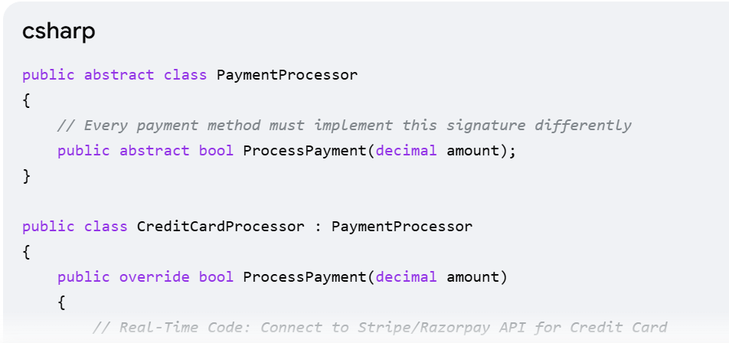 Abstraction in a Real-Time Project
- The Business Problem: Your app sends notifications (Order Confirmed, Password Reset). Today you use Twilio for SMS and SendGrid for Emails. In 6 months, management might want to switch to AWS SES. If your code relies directly on SendGrid classes, switching will break your whole project.
- The .NET Solution: Create a loose contract using an interface. Your business logic only talks to the interface, completely hiding the underlying provider.
DBContextconnectionpooling
Instead of creating and destroying a new DbContext instance for every single HTTP request, EF Core maintains a reusable pool of DbContext instances in memory.
- (DbContextOptions<PBMConfigDBContext> options)
- : base(options)
- {
- }
Your constructor immediately shouts those options upstairs to the foundation level via : base(options), opening the database pipeline safely.
• 🟢 NO (It's static/shared): Use AddSingleton. (Examples: Internal Caching, Email Configs, Azure Blob Clients, JWT Token Generators).
• 🔵 YES (It writes/reads private user data to SQL): Use AddDbContextPool. (Examples: Entity Framework DbContext handling Orders, Users, Payments, or Carts).
what is Base class
No Statics: You cannot use base inside static methods. It is strictly instance-bound.
Yes, absolutely! You send parameters from a child class to a parent class using the : base(...) syntax directly on the child class's constructor.
1. Calling a Parent Constructor (base(...))
If the parent class does not have a default (empty) constructor, the child class must explicitly pass parameters up using base(...).
2. Calling a Parent Method (base.MethodName())
If a child class overrides a parent class's method to change its behavior, it completely replaces the old logic. However, if you want to keep the parent logic and just add a little bit more code on top of it, you use base.MethodName().
_______________________some Exctra Questions ____________________________
what is shadowing
hides inherited member, use the new keyword")
public new string Nickname = "Young Boss";
Son person = new Son();
Console.WriteLine(person.Nickname); // Prints: "Young Boss"
Father person = new Son(); // Look at the variable type! It is 'Father' Console.WriteLine(person.Nickname); // Prints: "Old Boss

How to retur multiple values
use tuple
csharp
// Method definition using a named Tuple
public (int id, string name, bool isActive) GetUser()
{
return (101, "Alice", true);
}

// How to call it:
var user = GetUser();
Console.WriteLine(user.id); // 101
Console.WriteLine(user.name); // "Alice"
What is the use of SOLD principle
S - Single Responsibility Principle (SRP)
Definition: A class should have only one reason to change. It should do one job.
- Bad Practice: Creating a single controller or service that handles database queries, business logic, email notifications, and logging all in one place.
- Real-Time Project Example: Separating an Order Processing system into dedicated components.
2. O - Open/Closed Principle (OCP)
Definition: Software entities should be open for extension, but closed for modification. You should be able to add new features without changing existing code.
- Bad Practice: Using massive switch or if-else blocks to process different payment methods. Every time you add a new payment method, you risk breaking the existing ones.
- Real-Time Project Example: Using an interface to scale Payment Processing
- 3. L - Liskov Substitution Principle (LSP)
- Definition: Objects of a superclass should be replaceable with objects of its subclasses without breaking the application.

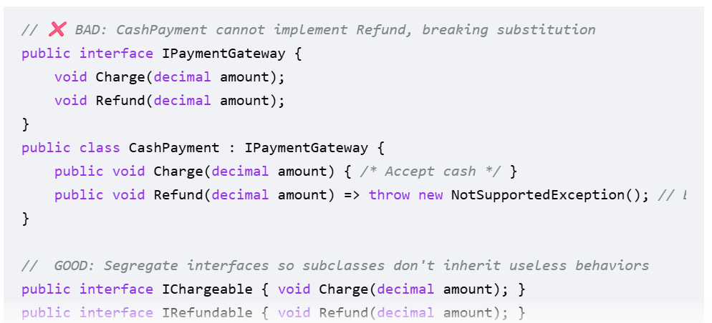

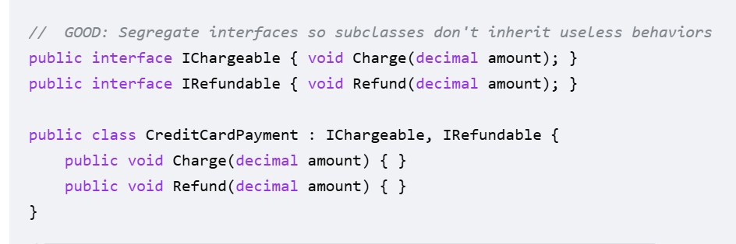
4. I - Interface Segregation Principle (ISP)
Definition: Clients should not be forced to depend on interfaces they do not use. It is better to have many small, specific interfaces than one fat interface
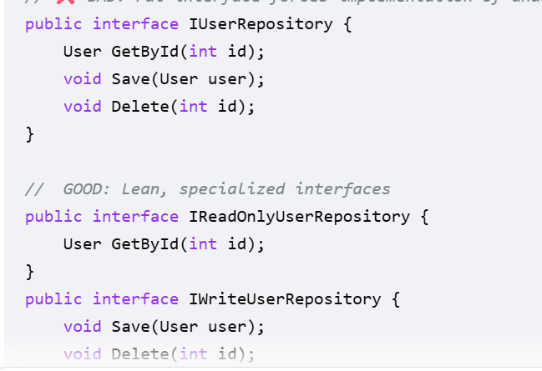
5. D - Dependency Inversion Principle (DIP)
Definition: High-level modules should not depend on low-level modules. Both should depend on abstractions.
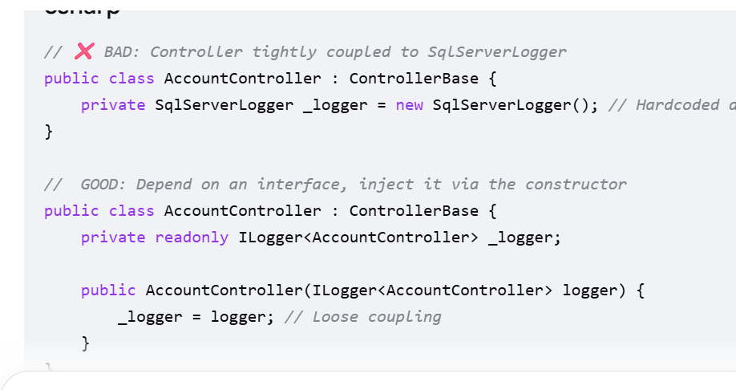
Difference between abstract class and interface
Feature | Abstract Class | Interface
Inheritance | A class can inherit from only one abstract class (Single inheritance). | A class can implement multiple interfaces.
Constructors | Can have constructors (used by derived classes). | Cannot have constructors.
Access Modifiers | Can use all modifiers (private, protected, public). | All members are implicitly public by default.
Performance | Slightly faster (uses direct lookup table). | Slightly slower (requires an interface lookup table).

What is routing
routing is the process of mapping an incoming request to its matching destination.
In webAPIs routingTypes
Attribute Routing __ [Route("api/v1/[controller]")]
Conventional Routing (Common for MVC) __ app.MapControllerRoute
Minimal API Routing (.NET 6+) ____ app.MapGet
In Angular Types
Imperative / Programmatic Routing _______-- this.router.navigate(['/dashboard']);
Declarative Routing:
Navigating directly inside your HTML template using standard Angular attributes.
<a routerLink="/profile">Go to Profile</a>
Lazy Loaded Routing
{ path: 'admin', loadChildren: () => import('./admin/admin.module').then(m => m.AdminModule) }
Dynamic / Parameterized Routing
{ path: 'product/:id', component: ProductDetailComponent } // Path: /product/42
What is the need of webapi if we can achive it by using MVC to return json data

Feature | MVC (Returning JSON) | Web API
Architectural Intent | Built to manage and serve HTML User Interfaces. | Built purely to serve Raw Data (Resources) to any client.
Content Negotiation | Hardcodes the output directly to JSON formats only. | Dynamically converts data to JSON or XML based on request headers.
Performance Overhead | Carries heavy overhead for parsing forms and Razor views. | Highly optimized, bypassing the view engine for faster data traffic.
Security & Integration | Defaults to cookie-based security meant for standard browsers. | Uses modern token-based security (JWT) and built-in CORS support for SPAs.

MVC Controller VS WEbAPI controller
Feature | MVC Controller | Web API Controller
Base Class | Inherits from Controller | Inherits from ControllerBase
Primary Return Type | Returns IActionResult containing an HTML View (View()). | Returns IActionResult containing raw data objects (Ok(data)).

Why we need controller
Controller because it acts as the brain or middleman of your application. It controls the entire flow of an HTTP request from start to finish
1. Listening and Routing
2. Model Binding and Validation (The Security Guard)
The controller takes raw text data from the HTTP request, converts it automatically into a C# object, and checks if the data is valid before processing it.
3. Interfacing with Business Logic (The Coordinator)
The controller does not do heavy math or direct database queries itself. Instead, it calls your Services or Repositories (the business logic) to get the work done.
- 4. Formatting the Response (The Translator)
Desgine patter and it types
1. Dependency Injection (Creational Pattern)
What it does: It handles how objects are created in memory [SOLID]
2. Repository Pattern (Behavioral/Data Pattern)
What it does: It handles how your code communicates with the database.
3. Unit of Work Pattern (Behavioral/Transactional Pattern)
What it does: It handles database transaction boundaries.
Fun dalegate
return values
Func<int, int, int> addNumbers = (x, y) => x + y; // How to call it: int result = addNumbers(10, 5); // Returns 15
what is different between machin.config and web .config
The machine.config file contains the baseline Microsoft system configurations
web. Config project configurations
app.config ,web.congif
• app.config is used for Console Applications (and Desktop apps like WPF or WinForms).
• web.config is used strictly for Web Applications (like hosted Web APIs and MVC websites) [SOLID].
appsettings.json
is the standard, modern configuration file used in ASP.NET Core (and .NET Core Console apps)
what is difference between .net core,asp.net web api,asp.net mvc,asp.net core mvc,asp.net core web api
Technology Name | Which Platform Engine? | Primary Output Target | Cross-Platform?
.NET Core | It is the platform engine. | Runs any console, background, or web app. | 🌍 Yes (Windows/Linux/Mac).
ASP.NET MVC | Legacy .NET Framework. | 🖥️ HTML Views | ❌ No (Windows Only).
ASP.NET Web API | Legacy .NET Framework. | 📊 JSON / XML Data | ❌ No (Windows Only).
ASP.NET Core MVC | Modern .NET Core. | 🖥️ HTML Views | 🌍 Yes (Windows/Linux/Mac).
ASP.NET Core Web API | Modern .NET Core. | 📊 JSON / XML Data | 🌍 Yes (Windows/Linux/Mac)

ArryList modrenList<T> and hash List
1. ArrayList (or List<T>)
Fetch data by using index position
it allows duplicates
It strictly maintains insertion order
Slow for large lists
Hash Table
Stores data as Key-Value pairs
Duplicates: Keys must be absolutely unique (Values can duplicate).
Type B: HashSet<T>
Stores a collection of individual, unique values without keys. [1, 2]
- Duplicates: It strictly forbids duplicate values. If you add "Alice" twice, it ignores the second one.
- Order: It does not maintain any order. [1, 2]
HashTable and Dictionary
HashTable :Handling Missing KeysReturning a missing key returns null.
- Dictionary It does not crash.Looking up a missing key throws a KeyNotFoundException crash.
Thread Pools Multithreading
multithreading and thread pools work together behind the scenes to make sure the system processes the claim quickly without crashing.
Thread: The smallest unit of execution in a computer
Multithreading:
- The ability of a CPU to execute multiple threads at the same time
- Thread Pool: A collection of pre-created, idle worker threads waiting for work
_____________________Extra Question in Angular____________________
Databinding
• Interpolation {{ value }}: Displays component data in the HTML.
- • Property Binding [src]="url": Passes data from TypeScript into an HTML attribute.
- • Event Binding (click)="save()": Sends user actions from HTML to TypeScript.
- • Two-Way Binding [(ngModel)]="name": Keeps the input box and TypeScript variable synchronized instantly.
Folder Strecture in Angular
my-angular-app/
- ├── src/
- │ ├── app/ <-- Main application logic
- │ │ ├── components/ <-- (Custom) Reusable UI components
- │ │ ├── services/ <-- (Custom) Global business logic / API layers
- │ │ ├── app.component.css
- │ │ ├── app.component.html
- │ │ ├── app.component.ts <-- The root component
- │ │ ├── app.config.ts <-- Modern config (Providers, Routing)
- │ │ └── app.routes.ts <-- URL routing rules
- │ ├── assets/ <-- Images, fonts, and static data
- │ ├── favicon.ico <-- Browser tab icon
- │ ├── index.html <-- The main host HTML webpage
- │ ├── main.ts <-- The application code entry point
- │ └── styles.css <-- Global CSS styles

what is custom diractives what is the use of this
custom directives to extract complex UI behavior out of your components
Date dractive,number ,decimal ,string diractives we can create that we can use all ares
Input Manipulation & Validation
Event Monitoring (DOM Events)
- A ClickOutsideDirective that detects if a user clicked anywhere outside a dropdown menu or modal popup so that it can automatically close it
Visual Transformations & Styling
Example: A HoverHighlightDirective that changes the background color or font weight of an item whenever a user hovers their mouse over it.
- Security & Permissions (Feature Access)
Example: An HasRoleDirective that automatically removes a delete button from the DOM if the current user doesn't have an 'Admin' role.
what is reanderrare and element ref
In Angular, ElementRef and Renderer2 (often typed as renderer) are two core utilities used to grab and manipulate HTML elements
ElementRef is essentially a pointer or a "handle". When you inject it into a custom directive or component, Angular hands you an object with a single property called nativeElement. This property holds the raw, physical HTML element from the webpage. [1, 2, 3]
- Renderer2 is a built-in Angular service designed for safe DOM manipulation
ElementRef is the pointer that holds your HTML element.
- Renderer2 is the tool that safely applies the background-color style to that element.
By using Renderer2.setStyle(), you ensure the background color is applied safely without bypassing Angular's security layers or breaking Server-Side Rendering (SSR).
Here is a quick, clean summary of how that looks in code:
// The safe, correct way to do it:
this.renderer.setStyle(
this.el.nativeElement, // The ElementRef target
'background-color', // The style you want to change
'lightblue' // The value to apply
);
life cycle events in angular what is the use
Lifecycle Hooks
Fetching data from a backend API
Cleaning up background tasks
Inspecting DOM elements safely
The Complete Lifecycle Flow
1. ngOnChanges()
2. ngOnInit()
3. ngDoCheck()
4. ngAfterContentInit() & ngAfterContentChecked()
5. ngAfterViewInit()
6. ngAfterViewChecked()
7. ngOnDestroy()
The Scenario | Which Hook to Use?
"I need to call an API to fetch user profiles immediately on load." | ngOnInit()
"I need to close a live chat socket connection before the page changes." | ngOnDestroy()
"I want to focus an input element using an @ViewChild reference." | ngAfterViewInit() [@viewChild]
"I need to react immediately
when a parent alters a
configuration value." ngOnChanges() [life cycle events in angular what is
the use]
The Scenario | Which Hook to Use?
"I need to read information from custom elements projected inside my component layout via <ng-content>." | ngAfterContentInit() [life cycle events in angular what is the use]
"I need to force a third-party canvas or chart library to redraw because a deep array value changed." | ngDoCheck() [life cycle events in angular what is the use]
"I need to auto-scroll a chat window to the bottom every single time a new message renders on screen." | ngAfterViewChecked() [life cycle events in angular what is the use]
how to create reactive form and dynamic forms
In Angular, Reactive Forms provide a structured, model-driven approach to managing form inputs where the state of the form is managed explicitly in your TypeScript code. Dynamic Forms build on top of reactive forms, allowing you to generate form controls automatically based on metadata (like a JSON payload from an API)
Call() ,apply()
function greet(greeting, punctuation) {
console.log(`${greeting}, my name is ${this.username}${punctuation}`);
}

const userProfile = { username: 'Amit' };

// Using call (arguments passed separated by commas)
greet.call(userProfile, 'Hello', '!'); // Output: "Hello, my name is Amit!"

// Using apply (arguments passed inside an array)
greet.apply(userProfile, ['Hi', '...']); // Output: "Hi, my name is Amit..."
Connection Pooling and DbContext Pooling both are same
1. Connection Pooling is about the NETWORK
network link between your application server and the database server
How it works: When you finish a query, the raw network pipe stays open and goes into a pool. The next time any query runs, it uses that already-open network pipe.
2. DbContext Pooling is about MEMORY (Application Layer)
Instead of destroying the DbContext object at the end of a web request, EF Core wipes its history clean (resets trackers) and puts the C# object into a pool. The next web request grabs that identical C# object out of memory.
SignalR
SignalR is a free, open-source library
SignalR allows the server to push content updates to connected clients instantly, the exact millisecond an event occurs

Feature | Hashtable | Dictionary<TKey, TValue> | HashSet<T>
Structure | Key-Value pairs. | Key-Value pairs. | Single unique elements.
Generics / Type-Safety | Non-Generic (stores everything as an object). | Generic (strongly typed at compile-time). | Generic (strongly typed at compile-time).
Performance | Slower (requires boxing/unboxing for value types). | Very Fast (no boxing/unboxing overhead). | Very Fast (optimized for mathematical set checks).
Missing Key Behavior | Returns null if the key doesn't exist. | Throws a KeyNotFoundException. | N/A (Uses .Contains() checking).
Namespace | System.Collections | System.Collections.Generic | System.Collections.Generic
Boxing is the process of converting a value type (like int, char, or struct) into a reference type (object), while unboxing is the reverse process of converting that reference type back into a value type.
HttpContext is a fundamental class in ASP.NET Core that encapsulates all information about a single, individual HTTP request and response

